Nottingham Trent University
School of Science and Technology

Behavioral Threat Detection in Small-Scale Cloud Infrastructures using Open Source Tool

by

Aditi Vaibhav Patil
in
2025

Project report in part fulfilment
of the requirements for the degree of
Master of Science
In
Cyber Security
I hereby declare that I am the sole author of this report. I authorize the Nottingham Trent University to lend this report to other institutions or individuals for the purpose of scholarly research.
I also authorize the Nottingham Trent University to reproduce this report by photocopying or by other means, in total or in part, at the request of other institutions or individuals for the purpose of scholarly research.

Signature
Aditi Vaibhav Patil

Abstract
Small-scale cloud infrastructures used by SMEs and educational institutions are often vulnerable to cyberattacks due to limited budgets and resources. Conventional intrusion detection systems are typically resource-intensive and unsuitable for such environments, highlighting the need for lightweight and open-source alternatives.
This project presents the development of a behavioural threat detection system that integrates Zeek for traffic monitoring with machine learning for classification. A controlled virtualised testbed was built in VirtualBox, where both benign and malicious traffic. Zeek was configured to capture flow-level traffic in JSON format, and a custom Python parser extracted a nine-feature schema. The dataset was cleaned and balanced which aligned with the Zeek dataset, and used to train and evaluate Logistic Regression and Random Forest models.
Results showed that Random Forest achieved perfect precision, recall, and F1-score across all classes, outperforming Logistic Regression. The model was deployed in a real-time pipeline capable of tailing Zeek logs, classifying flows, and sending automated alerts within a minute of suspicious activity. While limited by dataset size, simulation environment, and occasional misclassification of similar attack patterns, the system demonstrates that lightweight, open-source behavioural detection is both feasible and effective for SMEs.

Acknowledgements
I would like to express my sincere gratitude to my supervisor,Dr. Jon Robinson, for his invaluable guidance, encouragement, and constructive feedback throughout this project. His expertise and continuous support have been instrumental in shaping the direction and success of this work.
I would also like to thank my peers and colleagues who provided helpful discussions and moral support during the development process.
Finally, I am deeply grateful to my family for their patience, understanding, and unwavering encouragement during the course of my studies.

Table of Contents
Abstract ii
Acknowledgements iii
Table of Contents iv
List of Figures viii
List of Tables x
Chapter 1 : Introduction 11
1.1 Background and Problem Statement 11
1.2 Aim and Objectives 12
1.3 Scope and Significance 12
1.4 Structure of the Dissertation 13
Chapter 2 : Literature Review 14
2.1 Context and Importance of Cybersecurity in Small-Scale Cloud Environments 14
2.2 Foundations of Threat Detection 15
2.3 Behavioural Analysis in Threat Detection 16
2.4 Open Source Tools for Threat Detection 17
2.5 Zeek: A Behavioural Network Analysis Engine 18
2.6 Why Zeek is Ideal for Small-Scale Environment 19
2.7 Integration of ML with Open Source Tools 19
2.8 Summary of the Relevant Papers 20
2.9 Conclusion of Literature Review 21
Chapter 3 : New Ideas & Approach 23
3.1 Motivation and Rationale for the Approach 23
3.2 Proposed System 25
3.2.1 Design Philosophy and Objectives 25
3.2.2 System Components Overview 26
3.2.2.1 Packet Capturing 27
3.2.2.2 Zeek Logging and JSON Conversion 29
3.2.2.3 Feature Extraction 30
3.2.2.4 Machine Learning Classification & Identification 35
3.2.2.5 Prediction Logging and Storage 44
3.2.2.6 Alerting via SMTP 44
3.3 System Cost and Justification 47
3.4 Scalability and Resource Optimization 47
3.5 Professional, Ethical, Social and Legal Issues 48
3.5.1 Professional Issues 48
3.5.2 Ethical Issues 48
3.5.3 Social Issues 49
3.5.4 Legal Issues 49
3.6 General Project Planning 52
3.7 Summary 52
Chapter 4 : Implementation 54
4.1 Introduction 54
4.1.1 Environment Setup (VirtualBox Lab) 54
4.1.1.1 Virtual Machine Configuration in VirtualBox 54
4.1.1.2 Network Configuration 56
4.1.1.3 Zeek Installation and ML Environment Setup 58
4.1.1.4 Kali Attacker Tools Setup 60
4.1.1.5 Ubuntu Victim Services Setup 61
4.1.2 Traffic Capture 61
4.1.2.1 Dataset Traffic Capture (Experimental Phase) 62
4.1.2.2 Real-Time Traffic Capture (Operational Phase) 63
4.1.3 Zeek Logging & JSON Conversion 64
4.1.4 Dataset Preparation and Feature Extraction 66
4.1.5 Machine Learning Model Training 69
4.1.6 Real-Time Detection System 71
Chapter 5 : Evaluation 75
5.1 Introduction 75
5.2 Evaluation Methodology 75
5.3 Machine Learning Model Evaluation 76
5.4 Real-Time Detection Evaluation 77
5.4.1 Stress and Performance Testing 78
5.4.2 Limitations and Drawback of the system 79
5.4.2.1 Limitations of the System 79
5.4.2.2 Drawback of the System 80
Chapter 6 : Conclusion and Future Work 81
6.1 Summary of Findings 81
6.2 Delivery of Project Aim and Objectives 81
6.3 Future Enhancements 82
References 84
Appendix A 87

List of Figures
Figure 1 : Cybersecurity budget allocation among enterprises and SMEs ((Gartner, 2023),(Coalition, 2023)) 23
Figure 2 : System Flow 27
Figure 3 : Zeek Adoption by Organisation (Enlyft, 2025) 28
Figure 4 : conversion of zeek logs to JSON 30
Figure 5 : Python Parser Pipeline for Feature Extraction and Encoding 33
Figure 6 : A typical machine learning pipeline (roadmap.sh, 2024) 36
Figure 7 : Dataset Curation and Preprocessing 40
Figure 8 : Random Forest classification process (Analytics Vidhya, 2020) 43
Figure 9 : SMTP-based alerting workflow 45
Figure 10 : System Architecture Diagram 46
Figure 11 : VirtualBox Manager Displaying Configured Virtual Machines 55
Figure 12 : VirtualBox Network Adapter 1 Configuration 56
Figure 13 : VirtualBox Network Adapter 2 Configuration 57
Figure 14 : Connectivity check (kali -> zeek machine) 58
Figure 15 : Zeek is successfully installed 58
Figure 16 : Python installed successfully 59
Figure 17 : Dedicated folders created for attack simulation logs and live Zeek captures 60
Figure 18 : Zeek Real-Time Service Running in Promiscuous Mode on Interface enp0s3 62
Figure 19 : Directory Structure of Captured Attack Logs in Zeek 62
Figure 20 : Log Files Generated by Zeek in Real-Time 63
Figure 21 : conn.log before conversio to JSON 65
Figure 22 : conn.log after converted to JSON 65
Figure 23 : CICIDS 2017 dataset 66
Figure 24 : Python Script for dataset cleaning 66
Figure 25 : Global Label for the attacks 67
Figure 26 : Data splitting script 68
Figure 27 : Final training and testing dataset 69
Figure 28 : Python script for splitting 69
Figure 29 : model training and testing script 70
Figure 30 : Output of the training (Best Model : Random Forest) 70
Figure 31 : predict_realtime python script 71
Figure 32 : FTP attack from kali to the victim machine 72
Figure 33 : prediction logs are generated 72
Figure 34 : Zeek Alert 73

List of Tables
Table 1 : Research Papers Comparison 20
Table 2 : Comparison of Parsing Approaches for Feature Extraction 32
Table 3 : Observed Flow-Level Behaviours Used for Machine Learning Classification 34
Table 4 : Candidate Algorithms Reviewed for Model Selection 41
Table 5 : Virtual Machine configurations used for the experimental setup 55
Table 6 : Attacker Tools Installed on Kali Linux VM 60
Table 7 : Victim Services Installed on Ubuntu VM 61
Table 8 : Results and Model Comparison 76
Table 9 : Real-Time Detection Pipeline Timing and Responsiveness 78

Chapter 1 : Introduction

1.1 Background and Problem Statement
The rapid adoption of cloud computing has transformed how organisations, particularly small and medium-sized enterprises (SMEs), manage their infrastructure. Although the cloud offers flexibility and accessibility, it additionally exposes structures to new safety dangers that have been historically simpler to manipulate inside managed onpremise networks (ENISA, 2024). Unlike larger enterprises, SMEs often operate on limited budgets and cannot afford the expenses of purchasing, deploying, and maintaining large-scale security infrastructures. This imbalance makes small-scale cloud environments disproportionately appealing objectives for adversaries who increasingly rely on stealthy behavioural patterns rather than overt exploits to bypass defences (Verizon, 2025).
Traditional signature-based intrusion detection systems (IDS) are no longer sufficient, as attackers more and more mimic valid visitors via gradual slow brute-force attempts, low-rate denial-of-service attacks, or centered FTP brute-force campaigns. These are all network-level threats, where malicious activity is embedded within communication flows rather than in the applications themselves. Detecting such subtle anomalies requires systems that can model and learn behavioural baselines instead of relying only on static signatures (Moomtaheen et al., 2024). Open-source platforms such as Zeek provide a promising foundation by delivering rich monitoring capabilities without expensive licensing fees (Zeek Project, 2025). However, most behavioural detection studies nonetheless specializes in enterprise-level deployments, leaving a gap in lightweight, open-source solutions designed specifically for SMEs and their small-scale environments (Bagui et al., 2023).
This dissertation addresses this gap by designing, implementing, and evaluating a lightweight behavioural threat detection system that uses Zeek for data collection and machine learning for threat detection.

1.2 Aim and Objectives
Building on this identified gap, the project establishes a clear aim and set of objectives to guide its development and evaluation. The aim of this dissertation is to design, implement, and evaluate a lightweight behavioural threat detection system for small-scale cloud infrastructures using the open-source tool Zeek in combination with machine learning techniques, with a specific emphasis on detecting network-level threats. To achieve this, the project integrates Zeek’s monitoring and logging with Python-based anomaly detection in a simulated small-scale cloud environment (implemented using VirtualBox) that produces both benign and malicious traffic. Machine learning models are trained to distinguish normal behaviour from anomalies, and a real-time alerting mechanism is introduced to provide administrators with actionable notifications. The system is then evaluated for detection accuracy, false positives, and performance overhead, demonstrating that effective and affordable behavioural threat detection is feasible for small organisations operating under resource constraints.

1.3 Scope and Significance
The scope of this dissertation is limited to the detection of network-level threats in small-scale cloud infrastructures. The project does not attempt to address application-layer vulnerabilities or host-based attacks, instead it demonstrates how open-source technologies can be adapted to monitor and analyse network behaviour effectively in constrained environments. It is important to note that Zeek operates at the network layer, which means this project is focused exclusively on network-level threats and does not extend to application or host-based vulnerabilities (Zeek Project, 2025).
The significance of this work lies in its contribution to bridging the security gap faced by smaller organisations. By integrating Zeek with machine learning, the project highlights how network-level behavioural detection can be achieved without costly infrastructure or licensing fees. The findings provide a practical pathway for SMEs to strengthen their defences against modern attacks, while also offering an academic case study that advances research into lightweight, explainable, and open-source security solutions.

1.4 Structure of the Dissertation
This report is divided down into six main chapters (including this Introduction), Chapter 2 presents a comprehensive literature review, analysing prior work on behavioural threat detection, open-source intrusion detection systems, and the application of machine learning in cloud security, leading to the identification of the research gap. Chapter 3 introduces the methodology and proposed framework, outlining the system design, tool selection, and ethical considerations. Chapter 4 details the implementation process, including the configuration of the simulated cloud environment, the integration of Zeek with machine learning, and the development of the real-time alerting mechanism. Chapter 5 evaluates the framework through testing and analysis, examining detection accuracy, false positives. Finally, Chapter 6 concludes the dissertation by reflecting on the outcomes, discussing limitations, and proposing avenues for future work.

Chapter 2 : Literature Review

2.1 Context and Importance of Cybersecurity in Small-Scale Cloud Environments
Cybersecurity is now a central pillar of digital resilience rather than a specialist concern, as organisations increasingly depend on cloud infrastructures for service delivery, data storage, and critical operations. While enterprises invest heavily in layered defences and dedicated security teams, small and medium-sized enterprises (SMEs) are far more exposed. Limited budgets, fewer staff, and a reliance on third-party IT support create structural weaknesses that attackers exploit (Anand et al., 2023)
Contrary to the belief that cybercriminals only target high-value enterprises, SMEs are now prime victims. A 2023 global survey reported that more than 40% of cyberattacks were directed at small businesses (Bi et al., 2024). These incidents cause disproportionately severe consequences: financial disruption, erosion of customer trust, and prolonged downtime.
The disparity in budget allocation is striking. Whereas larger enterprises typically dedicate between 6–14% of IT expenditure to cybersecurity, SMEs often allocate less than 5% (Kazim and Zhu, 2016). Enterprise intrusion detection systems (IDS) or SIEM platforms demand significant financial outlay not only for licensing but also for infrastructure and ongoing maintenance (Alharbi and Khan, 2024). For SMEs, these solutions are unrealistic. As a result, many rely on minimal safeguards such as firewalls or antivirus software, which are ill-suited for stealthy attacks.

This economic reality makes lightweight, behavioural detection systems particularly relevant. Unlike traditional signature-based IDS, behavioural methods learn what constitutes normal system or network activity and flag deviations. When coupled with open-source monitoring tools, these methods provide SMEs with a cost-effective route to enhance detection capabilities (Rahmati, 2025). The literature highlights that effective security in small-scale cloud environments.

2.2 Foundations of Threat Detection
Threat detection is a cornerstone of organisational resilience. Even with strong preventive measures in place, detection provides the last line of defence by identifying suspicious or malicious activity before it escalates (Scarfone and Mell, 2007). Its evolution reflects shifts in both threat actor sophistication and defensive capacity.
The earliest systems relied on signature-based detection, matching traffic patterns, files, or activities against known malicious indicators. While effective for known threats, these systems are inherently reactive and struggle with zero-day exploits, polymorphic malware, or insider attacks (El-Badawy, Nasr and Khedr, 2025). Their static nature created blind spots in a rapidly evolving threat landscape.
In response, anomaly detection emerged, modelling “normal” behaviour and flagging deviations. This allowed systems to detect novel threats but introduced challenges such as high false positive rates and the need for significant tuning to avoid alert fatigue (Neupane, Sharma and Shakya, 2022).
The common thread across these approaches is the balance between coverage, accuracy, and efficiency. Signature-based systems remain fast and reliable for known threats but lack adaptability. Anomaly detection expands visibility to unknown attacks but risks overwhelming analysts with false positives. Behavioural detection brings contextual awareness, offering the most promise for evolving environments, yet it requires careful design and the right tools to avoid unnecessary complexity (Kommisetty et al., 2022; El-Badawy, Nasr and Khedr, 2025). What the literature makes clear is that no single technique is sufficient in isolation an effective detection depends on combining approaches in ways that match the resources and threat landscape of the organisation.

2.3 Behavioural Analysis in Threat Detection
Behavioural analysis has emerged as a cornerstone of modern cybersecurity by focusing on how systems and users behave over time rather than relying on static signatures. Each user, device, or service establishes a normal pattern of activity, and significant deviations from this baseline can indicate compromise or malicious intent (Kommisetty et al., 2022). The strength of this approach lies in its contextual awareness unlike anomaly detection, which may simply flag statistical outliers, behavioural models consider whether unusual actions are logical within the operational context (Rahmati, 2025). This ability to link activity with intent provides deeper visibility into stealthy or long-term threats that would otherwise go unnoticed.
For small and medium-sized enterprises, behavioural detection offers a practical pathway to stronger defences. Automated monitoring reduces the need for large security teams, while lightweight models can run efficiently on constrained infrastructure (Anand et al., 2023). Ethical and operational challenges remain, such as the risk of false positives or potential privacy concerns when monitoring user activity (Shaukat et al., 2020). However, advances in machine learning and explainable AI are helping to overcome these issues by improving accuracy and providing clarity on why alerts are raised (Arreche, García and De La Hoz, 2024).
As a result, behavioural analysis is increasingly recognised as both effective and accessible, particularly in resource-constrained cloud environments where traditional signature-based methods fall short.

2.4 Open Source Tools for Threat Detection
Open source tools play a central role in cybersecurity today, offering organisations practical and flexible ways to strengthen their defences. A key advantage is that they are budget-friendly compared to enterprise solutions, which often require costly licensing and dedicated vendor contracts. Open source alternatives can usually be deployed without major financial commitments, lowering the barrier to entry for organisations that cannot allocate large portions of their IT budgets to security (ENISA, 2021).
Equally important is their transparency. Unlike proprietary systems that operate as “black boxes,” open source tools make their source code available for review. This openness allows security teams to verify detection logic, audit functionality, and adapt tools to their own needs. It creates a higher level of trust and provides flexibility that vendor-controlled products often lack (Pothamsetty and Heidemann, 2022).
Another strength is their adaptability and continuous improvement. Open source communities contribute detection rules, patches, and enhancements at a rapid pace, ensuring that tools evolve quickly as new vulnerabilities and attack methods emerge (Wheeler, 2021). This collaborative development model effectively distributes innovation across a global community rather than relying on a single vendor.
Snort is one of the most established intrusion detection systems, capable of real-time packet inspection and logging (Wikipedia, 2023a). Suricata builds on this with multi-threading and deep packet inspection, enabling use in high-throughput environments (SecurityScorecard, 2022). OSSEC, a host-based intrusion detection system, provides capabilities such as log monitoring, file integrity checking, and rootkit detection (Wikipedia, 2023c).
Among network-focused tools, Zeek (formerly Bro) has gained prominence for its behavioural approach. Instead of focusing on signatures, Zeek generates rich, structured logs across multiple protocols and offers a script-driven framework for custom detection (Stamus Networks, 2023). Its focus on context makes it valuable both as a forensic tool and as a platform for advanced detection research.

2.5 Zeek: A Behavioural Network Analysis Engine
Zeek, formerly known as Bro, is an open source framework for network monitoring and threat detection developed in the mid-1990s (Paxson, 1999). Unlike traditional intrusion detection systems that rely mainly on static signatures, Zeek adopts a behavioural approach, recording structured logs of network activity across protocols such as HTTP, DNS and SSH. Its script-driven policy framework provides flexibility, enabling the development of tailored detection rules and supporting forensic analysis. Research shows that Zeek excels at capturing the context of activity and can detect malicious behaviour even when threats do not match predefined signatures (Sommers and Paxson, 2010; Khan et al., 2021).
For small-scale organisations, Zeek represents a practical option because it is both powerful and cost-effective. As an open source tool, it avoids the licensing costs of enterprise solutions, while still providing deep visibility into network behaviour. Its adaptability allows organisations to start small, customise detection policies to their environment, and integrate with machine learning models for improved accuracy (Mohan et al., 2022).

2.6 Why Zeek is Ideal for Small-Scale Environment
Zeek is particularly well suited for small-scale organisations because it combines affordability, flexibility, and deep visibility into network behaviour. As an open-source tool, it avoids the licensing costs of commercial intrusion detection systems, making it feasible for SMEs with constrained budgets (ENISA, 2021). Zeek generates structured logs across multiple protocols and applies a behavioural approach, enabling the detection of subtle or evolving threats (Sommers and Paxson, 2010). Its scripting framework allows administrators to customise detection rules. Supported by an active global community, Zeek provides small organisations with a practical, adaptable platform for effective intrusion detection (Khan et al., 2021).

2.7 Integration of ML with Open Source Tools
Machine learning (ML) has become one of the most influential technologies in cybersecurity because of its ability to recognise patterns in complex and fast-changing data. ML can learn from historical traffic, classify flows as benign or malicious, and adapt to new behaviours over time (Buczak and Guven, 2016). Supervised learning techniques allow accurate classification when labelled datasets are available, while unsupervised methods can uncover anomalies without prior knowledge (Sommer and Paxson, 2010).
When integrated with open source tools, ML extends their value significantly. Systems such as Snort, Suricata, and Zeek generate detailed logs, but ML provides the analytical layer that translates this raw data into meaningful detection. Zeek is particularly well-suited for this integration, as its structured, protocol-rich logs can be transformed into features for model training. Studies have demonstrated that combining Zeek with classifiers such as Random Forest improves anomaly detection in dynamic environments like the cloud (Mohan et al., 2022; Khan et al., 2021).
For organisations with limited budgets, this synergy provides a pathway to affordable yet advanced security. Open source tools supply transparent data collection, and ML offers adaptability and scalability, creating lightweight detection system that can keep pace with evolving threats.

2.8 Summary of the Relevant Papers
To critically evaluate existing research, the following table summarises and compares key scholarly and industry contributions. It highlights their focus, methodologies, findings and limitations, while positioning their relevance to this project.
Table 1: Research Papers Comparison
Author & Year | Focus Area | Key Contribution | Limitations | Relevance to project
Paxson (1999) | Introduced Bro (now Zeek) for network intrusion detection | Laid foundation for behavioural network monitoring | Outdated compared to modern high-speed networks | Establishes Zeek as the core open-source tool for behavioural detection
Sommer & Paxson (2010) | Use of ML for intrusion detection | Critiqued misuse of ML in IDS, proposed guidelines | Limited practical implementation at the time | Justifies cautious, structured integration of ML with tools like Zeek
Buczak & Guven (2016) | Survey of ML for intrusion detection | Mapped ML methods for cybersecurity use cases | Lacked cloud-specific evaluation | Framework for selecting ML models for behavioural detection
Khan et al. (2021) | Intrusion detection in cloud computing using Zeek + ML | Showed Zeek+ML improves detection of APTs in cloud | Focused only on cloud, limited SME context | Closely mirrors my integration approach in small-scale clouds
Mohan et al. (2022) | Network anomaly detection using Zeek + ML | Improved anomaly detection accuracy over signature IDS | Small-scale experimental setup | Validates my Zeek+ML methodology
ENISA (2021) | SME cybersecurity practices | Highlighted SME reliance on open-source tools | Observational, no technical solutions | Directly supports the projects focus and motivation

2.9 Conclusion of Literature Review
From the review of literature in Sections 2.1 to 2.8, several gaps become evident. While open source Zeek provide cost-effective intrusion detection, their deployment in small-scale cloud infrastructures remains underexplored. Existing research on Zeek demonstrates its strength in behavioural analysis, yet many studies focus on large-scale or enterprise contexts rather than SMEs. Similarly, although machine learning has shown promise in enhancing intrusion detection, practical frameworks that integrate ML with Zeek for resource-constrained environments are limited. These gaps highlight the need to investigate lightweight, explainable ML-driven threat detection using Zeek in small-scale cloud contexts.
Building on these insights, this dissertation addresses two central research questions:
- How can open source network monitoring tools such as Zeek be effectively integrated with machine learning models to build a lightweight, adaptive threat detection system tailored for small-scale cloud infrastructures?

- To what extent can the combination of behavioural network analysis and explainable machine learning enhance the detection of advanced and evolving cyber threats in resource-constrained environments such as SMEs, without incurring the limitations of traditional signature-based approaches?
In conclusion, the literature review highlights that while significant progress has been made in both open source intrusion detection and machine learning for cybersecurity, there remains a critical gap in aligning these advances with the practical needs of SMEs and small-scale cloud environments. This project positions itself at that intersection, aiming to design a system that is not only technically robust but also operationally feasible for resource-constrained settings. The next chapter outlines the methodology adopted to address these research questions, detailing the experimental design, tools and evaluation strategies.

Chapter 3 : New Ideas & Approach

3.1 Motivation and Rationale for the Approach
As highlighted at the close of Chapter 2, this dissertation identified two central research questions that remain insufficiently addressed in current practice. The motivation behind this project stems from the growing dependence on cloud infrastructures across businesses of all sizes and the limited capacity of smaller organisations to secure them. Large enterprises allocate between 6% to 14% of IT budgets to cybersecurity (Gartner, 2023), while many SMEs invest less than 2%, and almost 47% have no dedicated security budget at all (Coalition, 2023). This disparity exposes smaller infrastructures to the same advanced threats as large corporations but with fewer resources for defence.
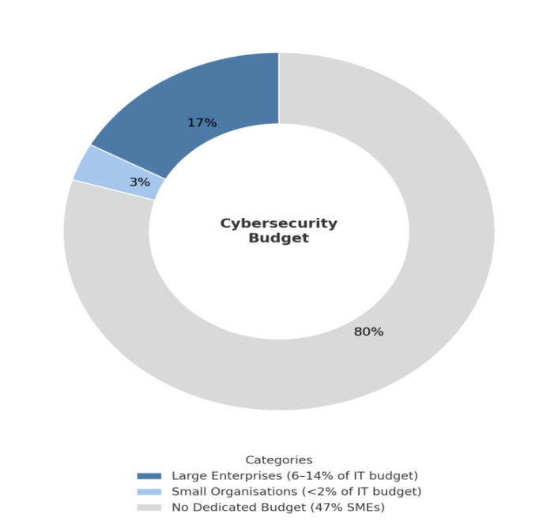
Figure 1: Cybersecurity budget allocation among enterprises and SMEs ((Gartner, 2023),(Coalition, 2023))
Open source solutions offer a practical response. Zeek, released under the BSD license, removes licensing costs while providing advanced protocol analysis and structured logging. Its accessibility and flexibility make it especially suitable for smaller-scale infrastructures, allowing enterprise-grade monitoring without financial overheads (Stamus Networks, 2023).
This project deliberately focuses on network-level threats, which remain both the most common and damaging. More than 60% of cyber incidents begin with network exploitation (Verizon, 2023), and events such as the Mirai botnet attack illustrate the potential scale of disruption. For small infrastructures, the network layer is also the most feasible monitoring point, as endpoint defences are often too resource-intensive.
The adoption of a behavioural approach further strengthens the rationale. Unlike signature-based intrusion detection, which only recognises known attacks, behavioural methods analyse activity patterns such as unusual connection states or packet ratios, enabling the detection of novel and polymorphic threats (Shapira and Shabtai, 2023). For organisations unable to maintain expensive signature updates, this adaptability is vital.
Artificial intelligence and machine learning reinforce this adaptability. By 2030, more than 60% of security systems are expected to rely on AI-driven anomaly detection (PwC, 2023). Integrating ML into this project ensures alignment with industry trends, while the focus on lightweight and explainable models contributes to academic research on practical, resource-efficient detection.
The workforce and skills gap adds urgency. Over 70% of SMEs cite the shortage of cybersecurity staff as their biggest barrier to improving defences (ISACA, 2022). A lightweight, automated, and explainable system can be operated effectively by non-specialist administrators, addressing this limitation.
Regulatory frameworks such as GDPR and PCI-DSS increasingly apply to smaller organisations, yet compliance is difficult without affordable monitoring. By leveraging Zeek and ML in a free, open source framework, this project provides a pathway to strengthen monitoring while supporting compliance.
Finally, the near universal adoption of cloud services, now over 90% of businesses (Flexera, 2023), expands the attack surface through shared resources and misconfigurations. A lightweight behavioural threat detection system integrated at the cloud level provides realistic protection for smaller users.
Taken together, the rationale is clear. This project addresses financial gaps, prioritises network-level threats, applies behavioural and ML-driven approaches, responds to workforce shortages, eases compliance pressures, and reflects the reality of cloud dependency. The following sections detail the methodology designed to answer the guiding research questions through a virtualised testbed, Zeek log collection, feature engineering, ML model training, and real-time deployment.

3.2 Proposed System
Building upon the motivations outlined in Section 3.1, this project proposes a lightweight behavioural threat detection system specifically tailored for small-scale cloud infrastructures. The system is designed not only to demonstrate technical feasibility but also to provide a practical, cost-effective, and explainable solution for organisations with limited resources. The following subsections present the system’s design philosophy, its core components, the justifications behind key technological choices, and an evaluation of scalability, cost, and potential limitations.

3.2.1 Design Philosophy and Objectives
The proposed system was developed with a clear philosophy to deliver effective threat detection for small-scale cloud infrastructures where enterprise-level tools are financially or operationally unfeasible. Smaller organisations often lack the resources for complex commercial intrusion detection systems, yet they face the same evolving threats as larger enterprises (Verizon, 2023). This system therefore prioritises efficiency, transparency, and cost-effectiveness, drawing on open-source technologies such as Zeek for monitoring and Python with scikit-learn for machine learning (McKinney, 2017; Zeek Project, 2025).
Its primary objectives can be summarised as four pillars:
- Lightweight Operation – operating on modest virtualised hardware without the need for deep packet inspection, by using Zeek’s structured logs (Sommer and Paxson, 2010).
- Behavioural Detection – identifying anomalies rather than relying on static signatures, ensuring resilience against new or polymorphic attacks (Shapira and Shabtai, 2023).
- Explainability – adopting interpretable models such as Random Forest to maintain transparency and build user trust (Breiman, 2001).
- Open-Source Accessibility – ensuring affordability and adaptability by using free, community-supported tools (Zeek Project, 2025).
Together, these objectives form the foundation of a system designed to be affordable, adaptive, and usable by administrators without specialist expertise.

3.2.2 System Components Overview
The proposed system follows a structured workflow that transforms raw network traffic into actionable threat intelligence. Starting from packet capture with Zeek, the process moves through logging, feature extraction, machine learning–based classification, and finally prediction storage with real-time alerting. The complete workflow is illustrated in Figure 2.

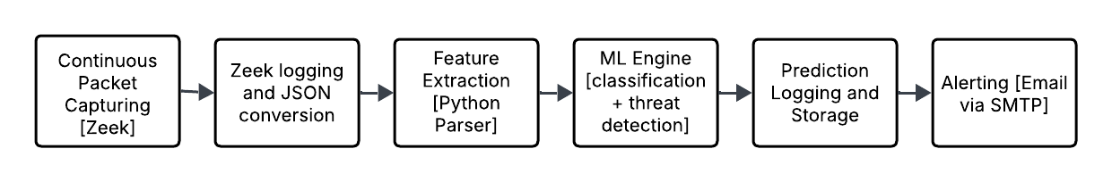
Figure 2: System Flow

3.2.2.1 Packet Capturing
Zeek has established itself as one of the most widely adopted open-source network monitoring and intrusion detection tools, trusted by organisations ranging from small businesses to large enterprises. Its strength lies in producing detailed behavioural metadata rather than relying solely on signatures, making it suitable for both research and operational environments. Recent industry surveys show that Zeek is deployed across all scales of organisations, with notable adoption in small and medium enterprises who require cost-effective yet powerful monitoring capabilities (Enlyft, 2025). This broad adoption demonstrates that Zeek is not limited to academic research but is actively relied upon in production settings, validating its selection as the foundation for this project.
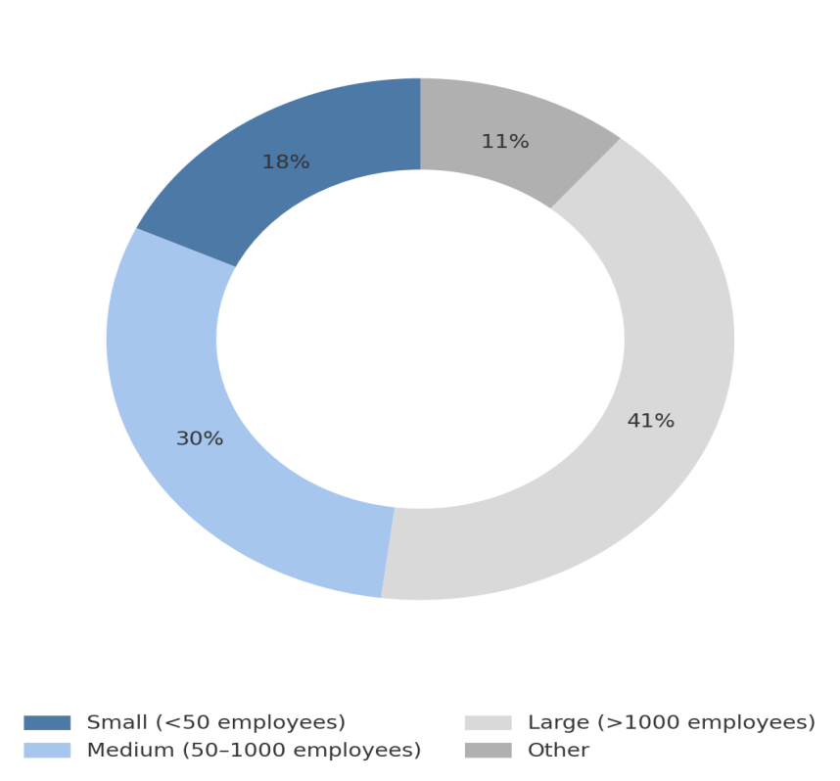
Figure 3: Zeek Adoption by Organisation (Enlyft, 2025)

Due to access and resource limitations, it was not feasible to deploy the system directly in a live cloud environment. To address this, we simulated the entire infrastructure within a VirtualBox lab that closely reflects the characteristics of a small-scale cloud. This setup allowed us to configure attacker, victim, and monitoring nodes on the same subnet, ensuring realistic traffic flows while remaining cost-effective and reproducible.
In the lab, Zeek was installed on a dedicated Ubuntu monitoring VM. The network interface enp0s3 was configured in promiscuous mode so that all packets traversing the subnet could be observed, regardless of their destination. This gave the monitoring node complete visibility of both benign user activity and simulated attacks such as port scans, brute-force logins, and denial-of-service attempts.
At the cloud level, the same principle applies but the deployment point shifts. Instead of attaching Zeek to a VirtualBox interface, it would be positioned at the network edge, where inbound and outbound traffic passes through a firewall or edge router. By connecting Zeek to a mirrored or SPAN port, it can capture all flows entering or leaving the cloud infrastructure without disrupting normal operations. This ensures that the behavioural detection demonstrated in the lab can be replicated in production-grade environments.
To make the system practical, we automated the Zeek service so that it starts listening as soon as the Ubuntu monitoring VM is powered on and stops when the system shuts down. While manual control is possible, automation was essential because attacks can occur at any time of day or night. This ensures continuous packet capture without requiring administrator intervention, a critical feature for small-scale organisations with limited staff resources.

3.2.2.2 Zeek Logging and JSON Conversion
Once the traffic capture setup is complete, Zeek is placed in promiscuous mode on the monitoring interface to ensure that it observes all packets traversing the network, regardless of destination. This configuration allows Zeek to act as a passive sensor without interfering with normal traffic flow.
To standardize the captured data for analysis and model training, Zeek’s default log format is configured to output in JSON format. JSON conversion brings several advantages:
- It simplifies downstream parsing and feature extraction in Python-based pipelines.
- It maintains structured key–value pairs, reducing ambiguity.
- It aligns seamlessly with ML workflows where logs can be directly ingested into pandas DataFrames or other frameworks.

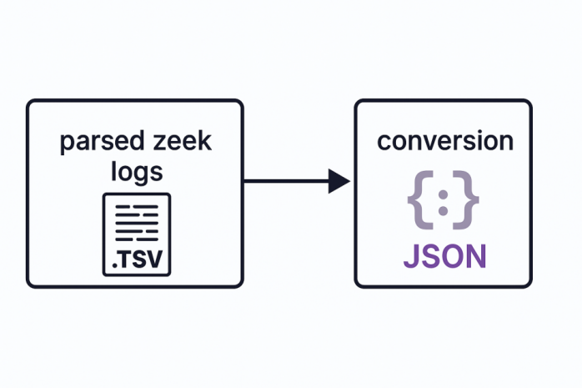
Figure 4: conversion of zeek logs to JSON

The automation scripts also introduced at this stage in our project such as:
- Start Zeek monitoring automatically on the specified NIC on turning the machine on.
- Convert and store logs in JSON format in a predefined directory (e.g., /home/aditi/zeek_live/).
- Apply proper permissions and naming conventions to avoid conflicts during dataset labeling.
This automated process ensures that data collection is consistent, reproducible, and ready for the feature extraction stage without requiring heavy manual intervention.

3.2.2.3 Feature Extraction
Once the conversion of the logs is done, the very next step in our system design is feature extraction. In machine learning, feature extraction refers to the process of selecting and transforming raw data into meaningful attributes that can be directly utilised by models for classification or prediction. Within the context of network security, this involves identifying protocol-level fields from Zeek’s JSON logs and converting them into numerical or categorical values that represent the behavioural characteristics of connections. Before beginning this stage, certain requirements were established to ensure reliability, the features must be lightweight enough to support real-time detection, consistent across multiple logging sessions, and aligned with both the CICIDS2017 dataset and the project’s small-scale cloud environment. Equally important is the prevention of redundancy and noise avoiding unnecessary fields that could either overfit the model or increase computational cost. By defining a clear schema and enforcing consistency in encoding, the system ensures that extracted features are not only technically valid but also practical for accurate behavioural threat detection.
Before finalising Python as the parser for feature extraction, we also considered alternatives such as Zeek scripting, Logstash each of which offered their own advantages during our initial review. We explored these options to understand whether they could meet the requirements of structured log handling and smooth integration with machine learning workflows. This exercise was useful in highlighting the strengths and weaknesses of different approaches, but after careful investigation and learning, Python emerged as the most suitable choice. Python was selected because it is one of the most widely adopted languages for data science, with rich ecosystem support in libraries such as pandas and scikit-learn (McKinney, 2017). Its extensive library support for data analysis, machine learning, and JSON handling, combined with its adaptability and large research community, aligned directly with the objectives of this project. More importantly, Python provides the flexibility needed to support our future plans, including explainable AI and an extensible detection pipeline. For these reasons, we decided to adopt Python as the foundation for the feature extraction stage.A short comparison of mentioned alternatives is summarised in Table 2 below, highlighting their advantages and limitations in the context of this project.

Table 2: Comparison of Parsing Approaches for Feature Extraction
Approach | Advantages | Limitations in our context
Zeek scripting | Runs at capture time, efficient for pre-filtering | Less flexible for ML workflows, requires custom Zeek script knowledge
Logstash | Enterprise-ready, integrates with SIEM and Elastic stack | Heavy for small-scale use, requires extra infrastructure and configuration
Python Parser | Flexible, lightweight, integrates with ML stack, easy reproducibility | Slightly higher development effort compared to pre-built log shippers

Before implementing the parser, we carefully identified what was needed to make it robust and aligned with the rest of our system. We first considered the environment itself, ensuring that Python 3 was installed with the right libraries such as pandas, scikit-learn, and the built-in json module. We faced small issues initially when parsing Zeek’s default ASCII logs, so we decided to enforce JSON as the standard format to avoid ambiguity and keep the workflow consistent. Once the logs were in JSON, the parser was designed to select only the attributes that we knew would matter for our machine learning pipeline. This meant aligning the fields between the CICIDS2017 dataset and Zeek’s conn.log, such as protocol, service, duration, byte counts, and packet counts. We engineered additional features like ratios to make the data more meaningful.
To ensure that the model could interpret these categorical values, integer encoding was consistently applied across sessions. Error handling was also considered, so that missing or malformed entries did not break the process. By following this approach, we built a parser that was lightweight, repeatable, and capable of bridging raw Zeek telemetry with our machine learning workflow.
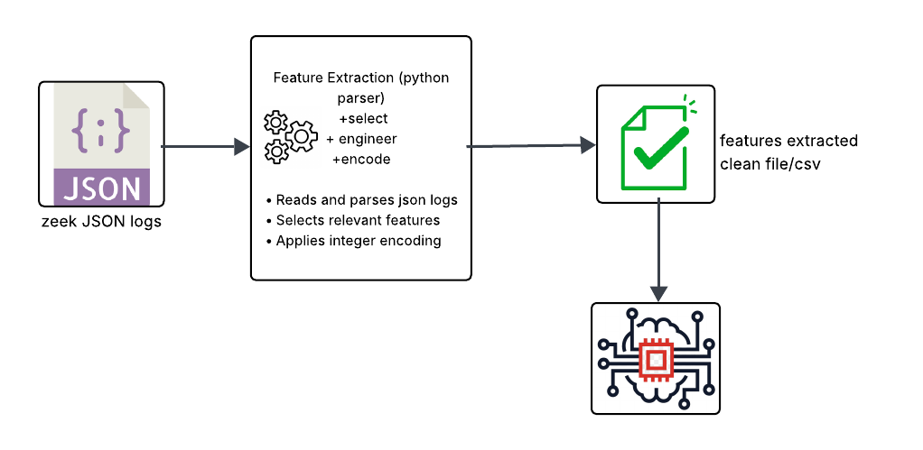
Figure 5: Python Parser Pipeline for Feature Extraction and Encoding

From the above figure, it can be seen that the Python parser developed in this project serves as the bridge between Zeek’s JSON logs and the machine learning pipeline.Its role was to ingest JSON-formatted logs, extract only the fields relevant to behavioural analysis, and transform them into a clean feature set that could be processed automatically by downstream models. By focusing on modularity, the parser ensured that each step selection, encoding, and transformation was executed consistently and reproducibly, turning raw telemetry into structured data without requiring manual intervention.
The feature schema was deliberately limited to nine carefully chosen attributes: protocol, service, duration, source bytes, destination bytes, source packets, destination packets, byte ratio, and packet ratio. These nine features were selected because they collectively capture both the context of a connection and the behavioural dynamics of communication which basically means how the system behave when they talk to each other over the network. Instead of just looking at what protocol is being used, we look at how much data is exchanged, how many packets are sent, how long the connection lasts, and whether the flow between the source and destination looks balanced or unusual Together, they provide a strong indication of whether traffic follows normal usage patterns or exhibits anomalies such as brute force attempts, scans, or denial-of-service activity. By aligning feature selection with both real-world traffic and benchmark datasets, the parser established a consistent foundation for learning patterns of malicious behaviour. Look at the table below for better understanding.
Table 3: Observed Flow-Level Behaviours Used for Machine Learning Classification
Traffic Type | Label | Duration (μs) | Src Bytes | Dst Bytes | Src Packets | Dst Packets | Observed Behaviour
Benign | 0 | 31,235 | 66 | 122 | 2 | 2 | Balanced traffic in both directions, typical request–response flow.
FTP-Patator | 7 | 9,057,763 | 116 | 188 | 9 | 15 | Uneven traffic with higher backward responses due to repeated login failures.
Port Scan | 10 | 62 | 2 | 6 | 1 | 1 | Extremely short connection with minimal data, consistent with probing behaviour.

From the table above, we can see how different traffic types exhibit distinct behaviours. In the case of FTP-Patator, we observed that the server consistently sends more data back to the client, with a higher count of backward packets compared to forward ones. We understood that this imbalance is the result of repeated login attempts, where the attacker sends short requests and the server generates larger error responses. This pattern of uneven exchange is what allowed us to conclude that such flows reflect brute-force behaviour.

We realised that this behaviour is typical of scanning tools, which probe multiple ports rapidly without establishing full sessions. By capturing these kinds of behaviours , balanced exchanges in benign flows, skewed responses in brute-force attempts, and short-lived probes in scans we concluded that our machine learning model could learn these distinctions. What we are essentially training the model to recognise is not just packets and bytes, but the behaviours behind them, which gives it the ability to generalise and flag similar attacks in future traffic. Thus, by aligning feature selection with both real-world traffic and benchmark datasets, the parser established a consistent foundation for learning patterns of malicious behaviour.
To ensure this data was usable by machine learning models, categorical fields such as protocol and service were encoded into integers, as models cannot process text labels directly. For example, “tcp” was mapped to 0, “udp” to 1, and “icmp” to 2, with mappings stored in a persistent dictionary for reproducibility across sessions. Additional engineering was applied to derive ratios and handle malformed or incomplete entries gracefully, preventing errors during batch processing. With these transformations in place, the parser produced a robust, numeric dataset ready for automated analysis. This completes the data preparation pipeline and leads directly into the machine learning engine, where models are trained, evaluated, and deployed for real-time behavioural threat detection.

3.2.2.4 Machine Learning Classification & Identification
Machine learning classification allows network flows to be labelled as benign or malicious, while identification links them to specific attack types. By applying these techniques to Zeek’s extracted features, raw traffic is transformed into actionable intelligence for real-time detection. In the following section, we discuss what machine learning is, and outline the requirements and steps that guided the training of our model.
3.2.2.4.1 Introduction to Machine Learning
Machine learning can be described as the ability of computers to learn patterns from data and improve performance as more information is processed (Mitchell, 1997). It is widely applied across domains such as healthcare, finance, and cybersecurity, where identifying anomalies or trends from large datasets is essential. The adoption of machine learning is expanding rapidly, global reports estimate that the ML market will grow from USD 21 billion in 2022 to over USD 209 billion by 2030, reflecting a compound annual growth rate of more than 38% (Fortune Business Insights, 2023). In cybersecurity specifically, recent surveys suggest that over 60% of modern intrusion detection and prevention systems now incorporate ML-based components (PwC, 2023). These figures highlight both the pace of adoption and the pivotal role machine learning is playing in reshaping how digital threats are identified and mitigated. As illustrated in Figure 6, the ML pipeline itself involves a sequence of processes from preparing and engineering data to selecting, training, and deploying models that together ensure predictive accuracy and operational relevance.
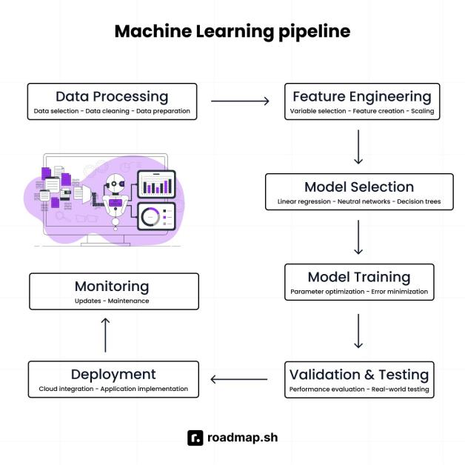
Figure 6: A typical machine learning pipeline (roadmap.sh, 2024)

3.2.2.4.2 The Role of Machine Learning in Project
When I looked across the various tools we could have used such as the classic rule-based intrusion detection, signature engines, or broader AI systems but the limitations quickly became clear. Signatures can't keep pace with new attack patterns, rule-based systems demand constant upkeep, and heavyweight AI introduces unnecessary complexity. In contrast, machine learning offered the perfect blend, it adapts to unseen behaviours, stays lightweight enough for real-time flow-level inference, and keeps our system interpretable. I knew that building a pipeline with Zeek flow logs, transforming them into a structured dataset, then training a model that learns from trends would be the analytical heart of the project. The skills I honed from Python and scikit-learn to data preprocessing and stratified testing, weren’t just technical requirements they were what made the system transparent, reproducible, and truly my own.
3.2.2.4.3 Dataset Selection and Justification
Choosing the right dataset was one of the most critical decisions in this project, since the accuracy of any supervised machine learning model depends directly on the quality and relevance of the training data. Several established intrusion detection datasets were initially reviewed, including KDD’99 and NSL-KDD. While historically important, these sets are now widely regarded as outdated and not reflective of modern traffic behaviours or attack strategies (Ring et al., 2019). After comparison, the CICIDS 2017 dataset was selected as the primary training source.
The CICIDS 2017 dataset offers a realistic mixture of benign and malicious traffic collected in a controlled environment, covering a wide spectrum of contemporary attacks such as Distributed Denial of Service (DDoS), brute-force logins, port scans(Sharafaldin, Lashkari & Ghorbani, 2018). Its flow-level features such as duration, byte counts, and packet counts aligns closely with the telemetry logs generated by Zeek, which made schema integration compatible. In addition, it provides ground-truth labels that are essential for supervised learning. These characteristics made CICIDS 2017 both academically validated and practically compatible with the small-scale cloud environment simulated in this research.
3.2.2.4.4 Dataset Preparation and Processing
After selecting CICIDS 2017 as the foundation, the next challenge was preparing a dataset that was both realistic and computationally manageable. The original files contained millions of rows across multiple CSVs, which, while comprehensive, would have been unnecessarily heavy for a small-scale environment like ours. We therefore applied sampling and balancing to bring the dataset down to 10,000 entries. This reduction was deliberate in my view, a 10k dataset provides a strong balance between diversity of traffic patterns and efficiency of training. It is large enough to represent meaningful behaviours but compact enough to ensure that models train quickly and reproducibly without requiring enterprise-grade hardware. Each major attack type available in CICIDS 2017 was represented in roughly equal ratios so that no single class dominated the model’s learning process.
Once this balancing was complete, the data had to be cleaned and labelled. This step was absolutely mandatory because the raw CSV files contained inconsistencies, missing values, and redundant formatting that could confuse the model. We created Python scripts to handle this process, and while the first attempts produced errors with character encoding and label mismatches, we refined the code until the pipeline was stable. By the end, we had a clean dataset where every record was consistently labelled according to a global mapping scheme that was defined. This consistency was essential for training, testing, and later real-time prediction.
In parallel, we also generated logs from Zeek’s conn.log within our VirtualBox environment. As discussed in earlier sections, this was important to ensure that the CICIDS dataset and our live Zeek logs shared common ground. By extracting the nine fixed features we created a schema that was identical across both sources. This alignment meant that the model trained on CICIDS would integrate seamlessly with Zeek in real time.
The final dataset was then assembled and divided into training and testing portions, following the standard 80:20 split used in machine learning research. This split ensured that the evaluation results were unbiased while still leaving enough data to learn the behavioural patterns of different attacks. With this stage completed, the dataset was now fully ready to be passed into the modelling stage.
To illustrate this entire process, Figure 7 presents the dataset preparation and processing workflow that we followed. It highlights the journey from CICIDS sampling and balancing, through data cleaning and labelling, to alignment with Zeek logs, common feature extraction, and finally the creation of training and testing sets. This figure captures the structured approach we used to guarantee both realism and reproducibility in building the foundation for machine learning classification.
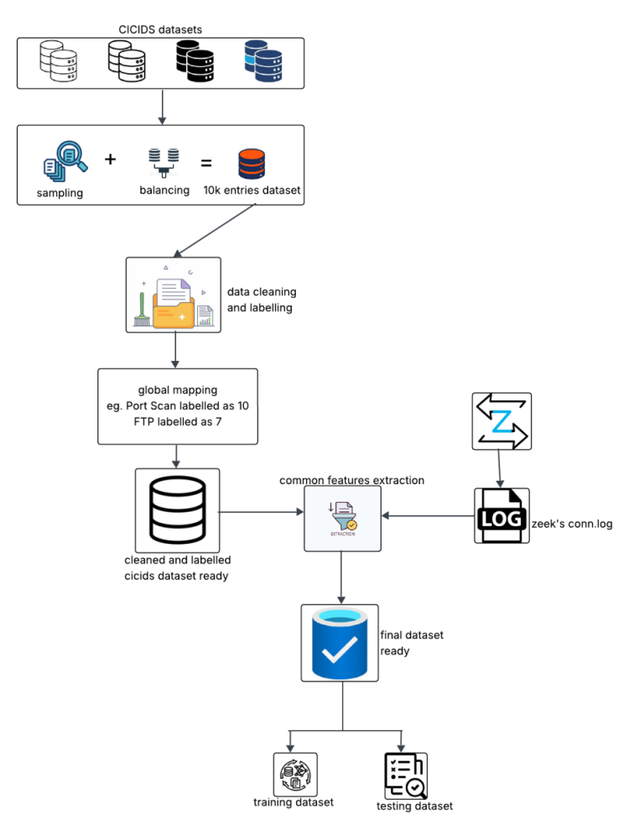
Figure 7: Dataset Curation and Preprocessing

3.2.2.4.5 Model/Algorithm Selection
When it came to choosing the right model, I had some step backs and reminded myself what a model really is in machine learning terms essentially, so, it is the trained outcome of an algorithm that learns from past data to make predictions on new, unseen inputs. The challenge was deciding which algorithm could meet the requirements of the project which is lightweight enough for small-scale infrastructures, explainable enough to be trusted, and powerful enough to capture complex traffic behaviours. After reviewing the options as shown in Table 4, I narrowed the field to two candidates they are Logistic Regression, a classic baseline known for its simplicity and interpretability, and Random Forest, an ensemble method recognised for its robustness in handling non-linear data. I trained both on the same dataset to ensure fairness, with the intention of later comparing their performance. This way, the process of model selection was not arbitrary but grounded in both practical constraints and the specific goals of the project.
Table 4: Candidate Algorithms Reviewed for Model Selection
Algorithm | Key Features | Relevance to the Project
K-Nearest Neighbour (KNN) | Intuitive, instance-based learning, requires no training phase | Slow in prediction, scales poorly, not ideal for large or streaming network data
Support Vector Machine (SVM) | Effective for binary classification, strong decision boundaries | High computational cost; less suitable for real-time small-scale environments
Random Forest | Ensemble of decision trees, handles non-linear data, robust against overfitting, feature importance available | Well-suited for complex traffic behaviours while remaining explainable
Logistic Regression | Lightweight, interpretable, provides clear probability outputs | Useful as a baseline classifier to benchmark performance in a simple, transparent way

Instead of relying on a single algorithm, we deliberately shortlisted two contrasting models for training and evaluation. The idea was to avoid a situation where one model underperformed and we would have to restart the selection process from scratch. By testing both Logistic Regression and Random Forest in parallel on the same dataset, we could directly compare their performance on equal grounds. This ensured that whichever model produced the stronger evaluation scores would be carried forward into real-time prediction, while the other served as a baseline reference for validation. In this way, model selection became both efficient and reliable.

To ensure fairness and reproducibility, both Logistic Regression and Random Forest were trained using a single Python script. This script handled the entire workflow that curated 10,000-row dataset, performing a stratified 80:20 train–test split, encoding categorical features, and then applying identical preprocessing steps to both algorithms. By using python script, I removed any risk of inconsistency between models and guaranteed that the evaluation compared like with like.
Once trained, both models were tested on the same 2,000 unseen rows. The results were clear that Logistic Regression struggled with the non-linear patterns of the data. Thes outcomes confirmed that Random Forest was far more capable of capturing the behavioural diversity of the traffic and generalising across multiple attack types.
Based on this evaluation, Random Forest was selected as the final model for deployment. From this point forward, all real-time predictions in the system were powered by the trained Random Forest model, ensuring that the behavioural threat detection engine remained both effective and explainable.
As illustrated in the Figure 8, the Random Forest algorithm strengthens reliability by combining the outputs of multiple decision trees to reach a final classification through majority voting. In the context of the project, each tree effectively evaluates the nine extracted Zeek features such as protocol type, connection duration, byte ratios, and packet counts to form an independent judgement about whether a flow is benign or malicious. Instead of relying on a single decision boundary, Random Forest aggregates the perspectives of many trees, which reduces the likelihood of overfitting and ensures that the model generalises well to unseen traffic. This ensemble approach is particularly valuable in small-scale cloud environments where data is heterogeneous. By pooling these different perspectives, the final Random Forest output provides both accuracy and robustness, ensuring that real-time alerts remain reliable even in the face of diverse or incomplete traffic data.
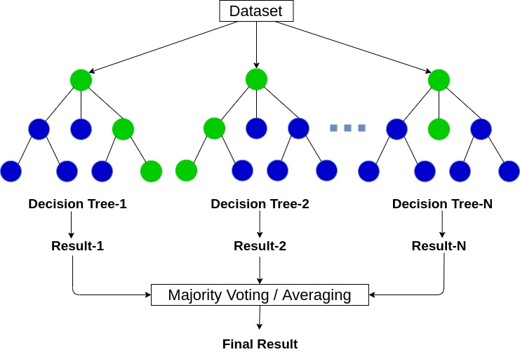
Figure 8: Random Forest classification process (Analytics Vidhya, 2020)

3.2..2..4.6 Training and Evalution
Once the evaluation confirmed Random Forest as the superior choice, the next step was to embed the trained model into the live detection workflow. This integration was designed to be seamless as the pre-trained model, saved as a .joblib file along with its feature schema, was directly connected to the Python parser that processed Zeek’s JSON logs. Each new network flow was transformed into the nine fixed features such as protocol type, service, duration, bytes, packets, and engineered ratios and then passed to the model for classification. This ensured that the exact same structure used in training was consistently applied in real time.
The predictions were generated instantly, labelling each flow as either benign or one of the attack categories. By aligning the schema between CICIDS 2017 and Zeek generated dataset, the model never faced mismatched features, which could have led to misclassifications. This consistency was the cornerstone of making Random Forest not just a research outcome but a deployable detection tool for small-scale cloud environments.
Random Forest provided the accuracy and robustness needed to handle diverse attack patterns, while feature importance scores preserved a level of interpretability for administrators. With this final integration, the training and evaluation phase reached its conclusion, and the focus shifted toward recording predictions and storing results for accountability and future analysis.

3.2.2.5 Prediction Logging and Storage
Logging was essential, not only for operational monitoring but also for providing traceability and accountability in later analysis.
Two layers of storage were implemented. First, Zeek continued to generate its raw logs (e.g., conn.log, http.log, ssh.log), preserving a complete record of network activity. Second, the ML engine outputted its predictions to a dedicated log file (zeek_predictions.log). Each entry captured the extracted features, the predicted label, and the timestamp, creating a transparent audit trail. These records can later be reviewed, exported, or integrated into higher-level dashboards if required.

3.2.2.6 Alerting via SMTP
Real-time detection only becomes meaningful if the results reach administrators quickly enough to trigger a response. For me, alerting was therefore just as important as classification itself it is the bridge between the model’s decision and an actionable security response. Without an alerting layer, even the most accurate prediction risks being buried in log files and overlooked until it is too late.
When considering options, I wanted something reliable, lightweight, and free of unnecessary infrastructure overheads. Enterprise SIEM platforms or proprietary messaging services felt excessive for the scale of this project. Gmail’s SMTP service, by contrast, provided a simple and widely accessible way to deliver alerts directly to an inbox. Configuring it with application-specific credentials stored in a .env file meant that sensitive information was protected, while the setup remained straightforward enough to be replicated in other small-scale environments.
Each alert was designed to be concise but informative. The subject line always read “Zeek Alert”, making it instantly recognisable, while the body specified both the attack type (e.g., PortScan, SSH Brute Force) and its corresponding numeric label from the training schema. This balance of human-readable and machine-consistent information made alerts both accessible to non-specialist administrators and trustworthy for long-term auditing.
As illustrated in the figure 9, once the ML engine detects a malicious threat, the alerting module is triggered automatically. This module uses securely stored .env credentials to connect with Gmail’s SMTP service and send out an email notification. The email is then delivered directly to the administrator’s inbox, ensuring real-time awareness of the incident. This workflow bridges the gap between detection and response, keeping alerts lightweight, secure, and immediately actionable.
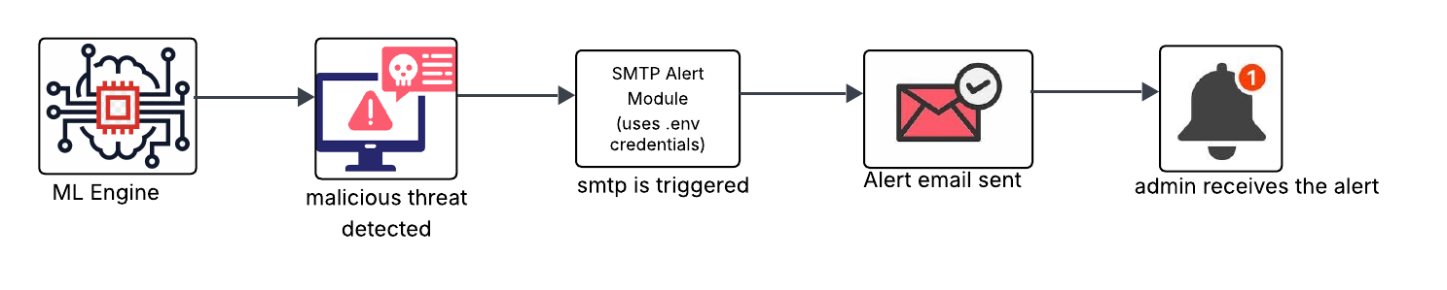
Figure 9: SMTP-based alerting workflow

With the alerting mechanism in place, the system achieves its full capability: from capturing raw traffic to delivering actionable alerts in real time. Each component traffic capture, Zeek logging, feature extraction, machine learning classification, prediction logging, and alerting now forms a unified workflow. The complete process is illustrated in Figure 10, which summarises how experimental design elements combine into a coherent architecture for behavioural threat detection.
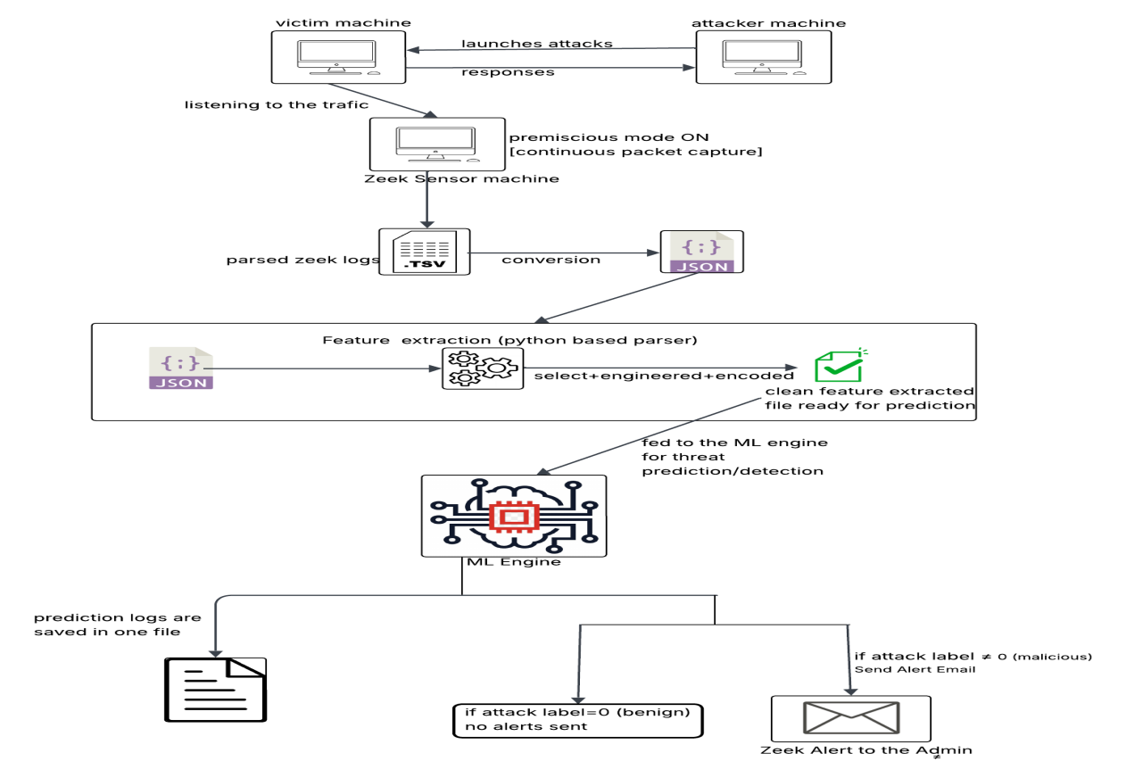
Figure 10: System Architecture Diagram

3.3 System Cost and Justification
Since this project was conducted in an experimental setup using VirtualBox and open-source tools, no direct financial costs were incurred during development. All core components that are Zeek for monitoring, Python and scikit-learn for machine learning, and Gmail’s SMTP for alerting are free to use under open licenses (Zeek, 2025; Pedregosa et al., 2011; Google, 2025).
However, I also considered how this system would translate into a real-world small-scale environment. In such cases, the main costs would not come from software but from infrastructure and maintenance. A small server or virtual machine instance (fan AWS or Azure cloud VM typically priced around £20–£40 per month depending on configuration) would be sufficient to host the Zeek sensor and ML pipeline (AWS, 2025; Microsoft Azure, 2025). Additional expenses may include basic storage for logs, email relay configurations, and routine administrative oversight. Compared to commercial intrusion detection systems, which often cost thousands in licensing and support (ENISA, 2022), this open-source approach offers a highly affordable alternative. In my view, the minimal financial requirements combined with the scalability of open tools make the system both practical and sustainable for SMEs or educational environments that cannot justify enterprise-level spending.

3.4 Scalability and Resource Optimization
In our experimental setup, we deliberately designed the system to be lightweight, running comfortably on a modest VM with very little CPU and memory consumption. However, once deployed on the cloud where traffic volumes can be much higher, scalability becomes crucial. The approach here would not be to rely on one powerful server but instead to distribute the workload across multiple lightweight Zeek sensors placed at different points in the network. These sensors would forward structured logs to a central analysis server running the machine learning model. By doing this, the system can handle larger loads smoothly, remain resilient even if one sensor fails, and still avoid expensive hardware.

3.5 Professional, Ethical, Social and Legal Issues

3.5.1 Professional Issues
In cybersecurity research, professional issues often involve reproducibility, transparency, and adherence to recognised standards, as many intrusion detection studies have been criticised for inaccessible datasets or undocumented methods (ACM, 2018; Ring et al., 2019). To counter this, my project used open-source tools such as Zeek and the validated CICIDS 2017 dataset (Zeek, 2025; Sharafaldin, Lashkari & Ghorbani, 2018). Every stage from dataset curation and attack simulation to feature extraction, model training, and deployment was documented with version-controlled scripts to ensure reproducibility. Neglecting such practices could undermine credibility; by embedding professional diligence, this project ensured technically rigorous and professionally reliable outcomes.

3.5.2 Ethical Issues
Ethical issues in cybersecurity research mainly arise from the risks of conducting live attack simulations and handling sensitive data. If not carefully managed, such experiments can unintentionally disrupt external systems or expose private information. To avoid this, all attacks in my project were executed strictly within an isolated VirtualBox environment, ensuring no traffic left the lab setup. Moreover, the analysis focused solely on flow-level metadata such as packet counts, durations, and byte ratios, deliberately avoiding payload inspection to minimise privacy concerns (Sommer & Paxson, 2010). The potential impact of neglecting these ethical safeguards would be severe, as it could not only compromise external networks but also breach participant trust and data protection norms. By adhering to these principles, the project maintained ethical integrity while still producing realistic and meaningful results.

3.5.3 Social Issues
Social issues in cybersecurity stem from the unequal access to effective security solutions, where small and medium-sized enterprises (SMEs) and educational institutions are often left vulnerable due to the high cost and complexity of commercial intrusion detection systems (ENISA, 2022). This project directly addresses that gap by building a lightweight, open-source alternative that is both affordable and usable without specialist expertise. In my experimental setup, the system demonstrated that meaningful behavioural detection can be achieved on modest hardware, making it realistic for resource-constrained environments. The potential impact of this approach is significant: by empowering smaller organisations with accessible tools, the project not only strengthens their resilience against cyber threats but also contributes to the broader societal goal of improving overall digital security.

3.5.4 Legal Issues
Legal issues in cybersecurity research mainly concern data protection, privacy, and compliance with regulations such as GDPR (2016). To avoid crossing legal boundaries, this project strictly focused on metadata (packet counts, byte ratios, connection durations) and excluded payload content, ensuring no personally identifiable information (PII) was processed. All experiments used open datasets and controlled simulations (Sharafaldin, Lashkari & Ghorbani, 2018), reducing legal risks. Neglecting such safeguards could lead to compliance breaches, reputational damage, and liability. By following established legal principles, the project ensured its methods were academically valid and real-world compliant.
Having now detailed the design principles, system components, and professional, ethical, social, and legal considerations of the proposed approach, the discussion naturally turns back to the core research questions that guided this study.
- RQ 1: How can open-source network monitoring tools such as Zeek be effectively integrated with machine learning models to build a lightweight, adaptive threat detection system tailored for small-scale cloud infrastructures?
Answer : This project demonstrated that integration is possible by aligning Zeek’s structured network telemetry with a streamlined machine learning workflow. Instead of relying on raw packet captures, Zeek was configured to generate compact behavioural records that were parsed into a fixed nine-feature schema. This ensured that the data was consistent, reproducible, and efficient to process on modest hardware. By reducing the dataset to a balanced 10,000 entries, the system retained behavioural diversity while remaining lightweight enough for small-scale environments that cannot afford enterprise-level resources.
The adaptive element was achieved by embedding the trained Random Forest model directly into the real-time pipeline. Each flow recorded by Zeek was transformed into the defined features, classified instantly, and logged for auditability. Alerts were generated automatically, meaning that administrators could respond without needing specialist expertise. Together, these steps showed that Zeek can be tightly coupled with machine learning to deliver a system that is both resource-conscious and operationally practical, answering the challenge of deploying behavioural threat detection in small-scale cloud infrastructures.
- RQ 2 : To what extent can the combination of behavioural network analysis and explainable machine learning enhance the detection of advanced and evolving cyber threats in resource-constrained environments such as SMEs, without incurring the limitations of traditional signature-based approaches?
Answer : The project confirmed that behavioural network analysis, when combined with explainable machine learning, provides a clear advantage over static, signature-based systems. By focusing on features such as packet ratios, byte distributions, and connection durations, the system was able to capture anomalies that do not rely on pre-defined attack signatures. This meant that previously unseen or modified threats, such as variations of denial-of-service or brute-force activity, could still be identified through their abnormal behaviour rather than their exact pattern.
Explainability played an equally important role. Using a Random Forest model ensured that predictions were not only accurate but also interpretable, with feature importance highlighting which network characteristics drove each classification. This balance between accuracy and transparency makes the system practical for SMEs, where administrators may lack deep expertise but still need to understand why an alert was raised. Overall, the project demonstrated that combining behavioural analysis with explainable machine learning significantly improves adaptability, enabling effective threat detection in constrained environments without the rigidity and blind spots of traditional signature-driven IDS tools.

3.6 General Project Planning
This is a general high-level plan outlining how the project was carried out. A few tasks were sometimes achieved earlier or later than scheduled and were adjusted accordingly.
The first phase (WC 01-06-2025 to WC 30-06-2025) was dedicated to background research, setting up the VirtualBox environment, and configuring Zeek for initial traffic capture.
The second phase (WC 01-07-2025 to WC 31-07-2025) focused on dataset preparation, including cleaning, balancing, and integrating CICIDS2017 with Zeek logs. During this period, the Python parser and nine-feature schema were finalised, followed by initial model training and comparison between Logistic Regression and Random Forest.
The final phase (WC 01-08-2025 to WC 26-08-2025) concentrated on refining the Random Forest model, building the real-time predictor pipeline with email alerts, and conducting stress testing. Alongside implementation, this phase also included writing the dissertation documentation, preparing architecture diagrams, and generating figures to clearly illustrate the system’s design and evaluation.

3.7 Summary
Chapter 3 laid the foundation for the system by moving from motivation into design and methodology. We began by showing why a lightweight, behavioural approach was necessary for small-scale cloud infrastructures, then carefully justified the use of Zeek for traffic capture and Python-based parsing for feature extraction. A balanced dataset was created by combining CICIDS 2017 with simulated Zeek logs, ensuring both efficiency and diversity. For model selection, we compared multiple algorithms before training both Logistic Regression and Random Forest, ultimately choosing Random Forest for its accuracy and interpretability. The chapter also explored logging, alerting, and automation as essential components to make the system usable in practice. Finally, professional, ethical, social, and legal considerations, along with costing and scalability, were discussed to ground the approach in real-world feasibility. Together, these elements answered the guiding research questions and prepared the ground for the actual implementation described in Chapter 4.

Chapter 4 : Implementation

4.1 Introduction
Building on the design and methodological foundations established in Chapter 3, this chapter demonstrates how the proposed system was implemented and investigated in practice. The aim here is not only to validate the architecture but also to provide transparent evidence of its development, testing, and performance.
In the sections below, the implementation is presented step by step, showing how each component was set up, executed, and validated in alignment with the design.

4.1.1 Environment Setup (VirtualBox Lab)

4.1.1.1 Virtual Machine Configuration in VirtualBox
As this project required an isolated environment for controlled experimentation, the entire setup was deployed on VirtualBox. Due to limited access to commercial cloud platforms, VirtualBox was chosen to replicate a small-scale cloud infrastructure, ensuring that the testbed closely mirrors real-world deployment scenarios.
Below is the attached VirtualBox screenshot on which all the virtual machines (VMs) are hosted.The setup includes Kali Linux as the attacker machine, Ubuntu instances as victim servers, and a Windows VM for additional target testing, together forming a controlled small-scale cloud infrastructure.
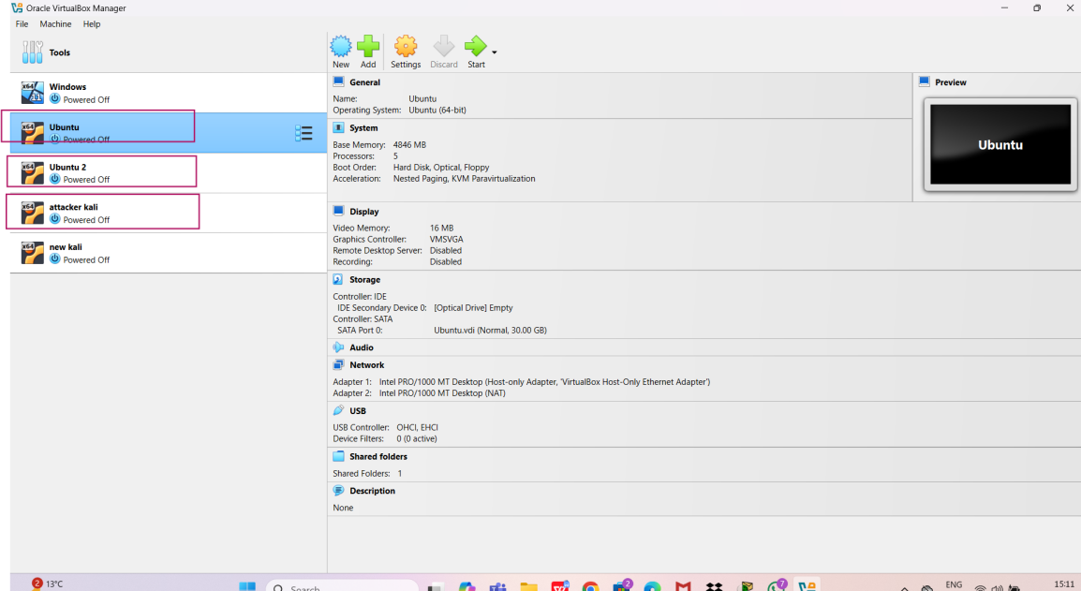
Figure 11: VirtualBox Manager Displaying Configured Virtual Machines
The specifications of each virtual machine used in the experimental setup are summarised in the table below. These configurations define the resources, operating systems, and roles assigned to each VM within the controlled test environment.
Table 5: Virtual Machine configurations used for the experimental setup
VM Name | Operating System | CPU | RAM | Disk Size | Network Adapters | Role in the Experiment.
Attacker Kali | Kali GNU/Linux Rolling 2025.2 | 7 | 4 GB | 25 GB | Adapter 1: Host-Only  Adapter 2: NAT | Attacker Machine
Ubuntu 2 | Ubuntu (64-bit) | 5 | 4 GB | 25 GB | Adapter 1: Host-Only  Adapter 2: NAT | Victim Machine
Ubuntu | Ubuntu (64-bit) | 5 | 4 GB | 30 GB | Adapter 1: Host-Only  Adapter 2: NAT | Monitoring Sensor & Log Collection

4.1.1.2 Network Configuration
To ensure reliable communication between the virtual machines, a dual network adapter configuration was implemented. Each VM was assigned a Host-Only adapter to create an isolated internal network for traffic monitoring, and a NAT adapter to provide internet access for updates and tool installations.
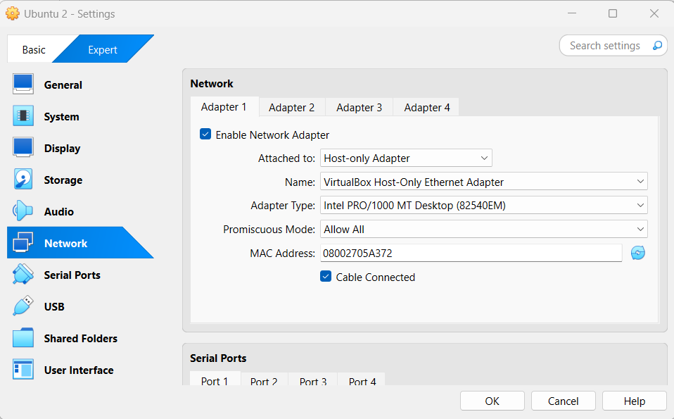
Figure 12: VirtualBox Network Adapter 1 Configuration
The figure 12 shows Adapter 1 attached to the Host-Only Adapter, which forms the isolated internal lab network. This configuration ensures that all traffic between VMs remains within the controlled environment and can be monitored by the Zeek sensor.

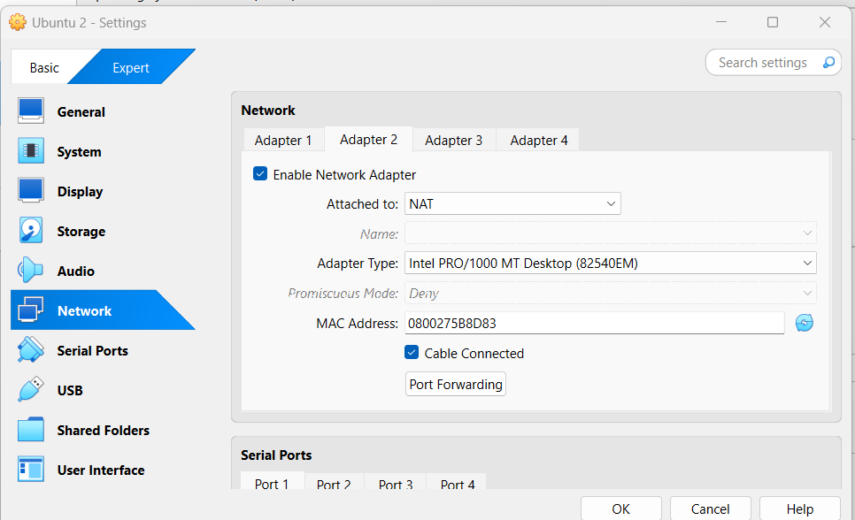
Figure 13: VirtualBox Network Adapter 2 Configuration

The above figure shows Adapter 2 attached to NAT (Network Address Translation). This configuration allows the VM to access the internet for downloading updates and tools, while keeping experimental traffic isolated from the external network.
NOTE : The Adapter 1 (Host-Only) and Adapter 2 (NAT) configurations shown above were applied consistently across all virtual machines to ensure they operated within the same controlled internal network while maintaining external connectivity for updates.
Now, we have to check the connectivity between the vm’s. Thus with the help of ping command the readiness will be checked.
Command : ping 192.168.56.102 (we are testing this from kali machine to the zeek machine) below is the screenshot attached for it.
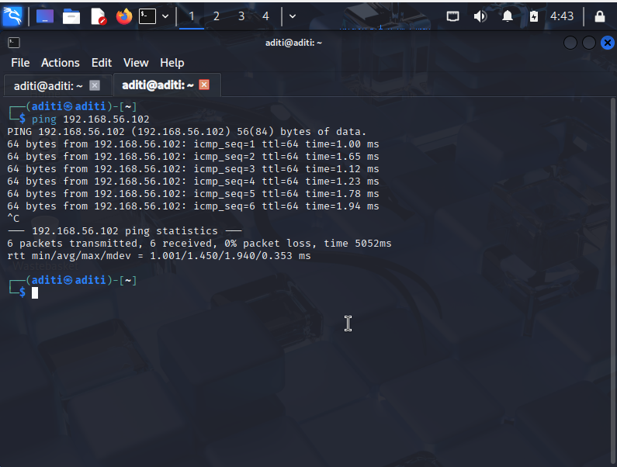
Figure 14: Connectivity check (kali -> zeek machine)

Similarly, the connections are tested between all the vm’s, so that no error is faced in the later stages of the execution.

4.1.1.3 Zeek Installation and ML Environment Setup
All monitoring and data processing are performed on the Ubuntu VM running Zeek. The same machine hosts the Python environment used for feature extraction and model training to keep the pipeline reproducible and self-contained.
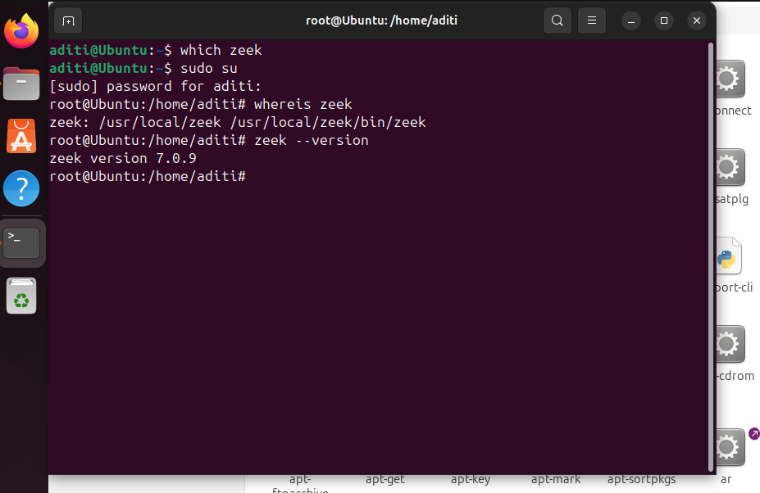
Figure 15: Zeek is successfully installed

The above figure shows that zeek is installed under /usr/local/zeek/ with the executable located in /usr/local/zeek/bin/zeek and the zeek version is 7.0.9.
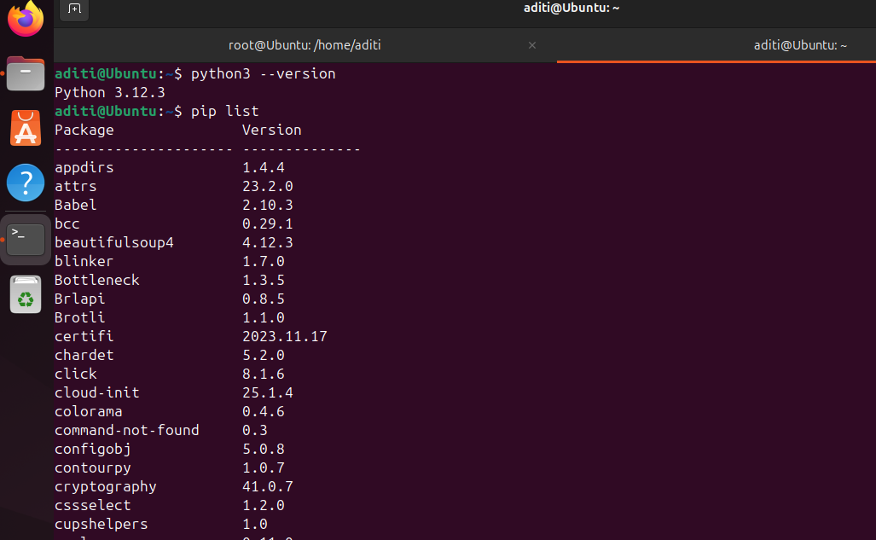
Figure 16: Python installed successfully
The output shows that the system is running Python 3.12.3, confirming the environment is up to date. The pip list command displays all installed Python packages with their versions, indicating that the environment is properly equipped with the required libraries. This ensures compatibility for tasks such as log parsing, feature extraction, and training machine learning models, which are central to the project workflow.
Now, we have created specific folders, that are shown in the figure 17,these highlighted folders zeek_attacks and zeek_live were created to organise the outputs of Zeek. The zeek_attacks directory stores logs generated during controlled attack simulations, while the zeek_live directory is used for real-time traffic captures.

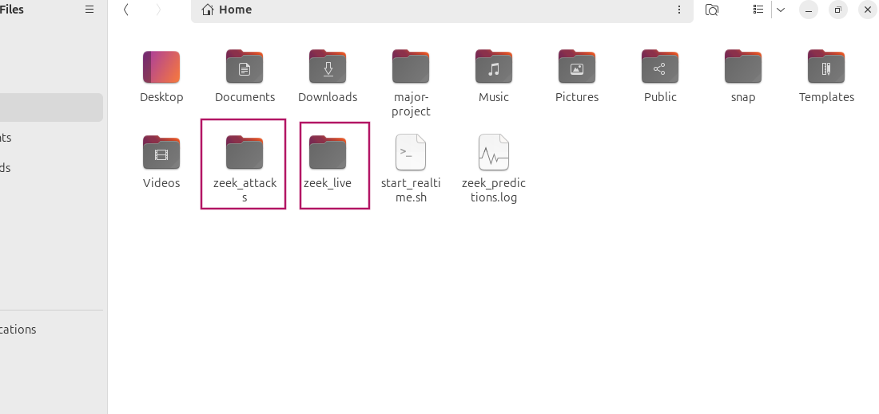
Figure 17: Dedicated folders created for attack simulation logs and live Zeek captures

4.1.1.4 Kali Attacker Tools Setup
The Kali Linux machine was configured with a range of penetration testing tools required for simulating different attack scenarios. These tools enabled the generation of brute-force, denial-of-service, and scanning behaviours used to test the monitoring and detection capabilities of the system
Table 6: Attacker Tools Installed on Kali Linux VM
Tools | Purpose for installation
Hydra | Brute-force password guessing on services
Nmap | Network scanning and reconnaissance
Hping3 | Packet crafting and flooding for DoS
Slowloris | Application-level HTTP DoS

4.1.1.5 Ubuntu Victim Services Setup
The Ubuntu VM was configured to run essential services targeted during attack simulations. These services provided the necessary environment for generating realistic traffic patterns that could later be monitored and classified by the detection system.
Table 7: Victim Services Installed on Ubuntu VM
Service | Purpose in Experiment
OpenSSH | Provides secure shell access
Apache2 | Hosts web services
vsftpd | Provides FTP access

With the victim services installed and verified, the Ubuntu machine is fully prepared to act as a target for brute-force and denial-of-service attacks. This configuration ensures that realistic traffic scenarios can be generated for monitoring and analysis in the subsequent stages of the experiment.

4.1.2 Traffic Capture
In this project, traffic capture was carried out in two distinct phases. The first phase involved controlled experiments where benign and malicious traffic were generated to create a labelled dataset for training the machine learning model. The second phase focused on real-time monitoring, where Zeek continuously captured live flows and stored them in its conn.log files, which served as the input for the detection pipeline. This two-stage approach ensured that the system was both trained on diverse attack scenarios and validated under realistic operational conditions.

4.1.2.1 Dataset Traffic Capture (Experimental Phase)
During the experimental phase, Zeek was deployed in promiscuous mode on the sensor VM to monitor all packets traversing the Host-Only network. Controlled attack simulations and benign activities were executed between the attacker (Kali) and victim (Ubuntu) machines. As illustarted in the figure below, zeek is activated and is listening on the network.
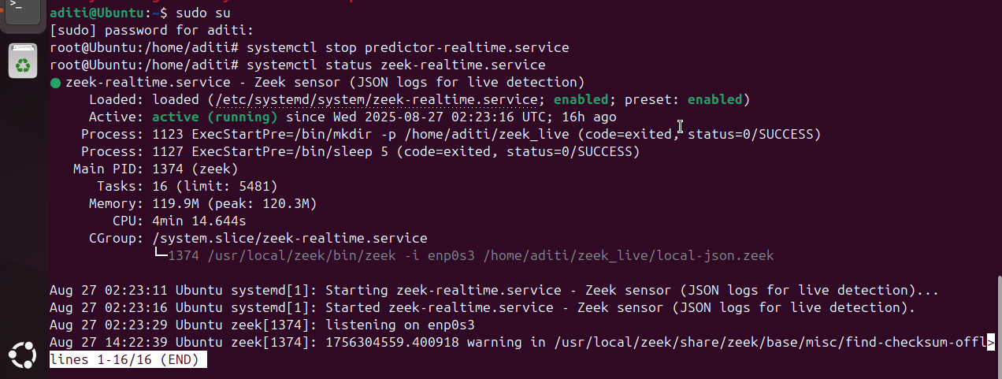
Figure 18: Zeek Real-Time Service Running in Promiscuous Mode on Interface enp0s3
The resulting logs were stored in organised directories (e.g., /home/aditi/zeek_attacks/portscan/) to maintain clear labelling for later integration with the CICIDS dataset.
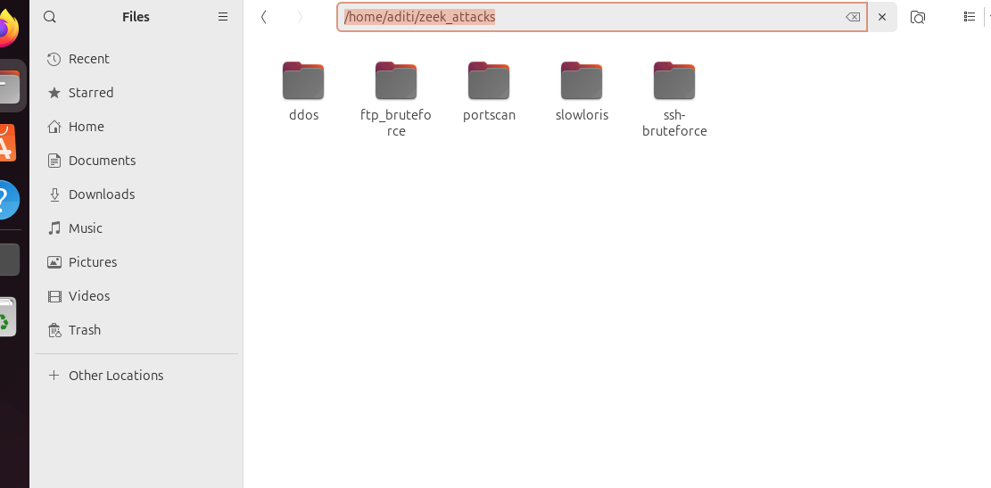
Figure 19: Directory Structure of Captured Attack Logs in Zeek

4.1.2.2 Real-Time Traffic Capture (Operational Phase)
Just like 4.1.2.1 the zeek’s does the same activity on listening on the network, but in this real-time traffic capture, we actually made a service for zeek to start running automatically when the zeek machine is powered on to reduce the manual activity and this zeek_realtime service is managed through systemd, ensuring that Zeek automatically started, logged traffic, and wrote outputs into the designated zeek_live directory. Among the different log files generated, the conn.log file played the central role, as it contains detailed flow-level metadata such as protocol, service, packet counts, and byte counts. This log served as the primary input for the feature extraction pipeline and subsequent machine learning classification.
The below image shows the location of the diretory wherein the live logs are stored and then processed further.
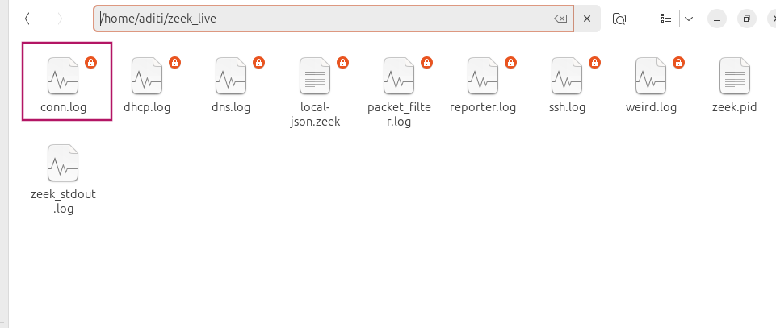
Figure 20: Log Files Generated by Zeek in Real-Time

Thus, the real-time traffic capture mechanism ensured that all flows were continuously logged and stored in structured files, with conn.log serving as the core input for further analysis. The next stage involves converting these logs into JSON format

4.1.3 Zeek Logging & JSON Conversion
From the traffic capture step, it was observed that multiple logs were generated by Zeek in real time. Few of them are mentioned below:
- conn.log → Contains flow-level metadata such as protocol, service, duration, packets, and bytes, making it the primary input for feature extraction and machine learning.
- ssh.log → Records SSH-specific activity, useful for detecting brute-force login attempts.
- weird.log → Captures unusual or anomalous network behaviours, often highlighting suspicious events not categorised elsewhere.
To enable downstream processing, these log files were converted into JSON format. This was achieved using the following command, executed within the active Zeek directory:
Command : zeek -C -r traffic.pcap local "LogAscii::use_json=T"
In simple words, the above command instructs Zeek to analyse a previously recorded packet capture file without discarding packets due to checksum errors, apply the standard local analysis scripts, and store all resulting logs in JSON format. This ensures the captured traffic is preserved in a structured format suitable for parsing and machine learning workflows.
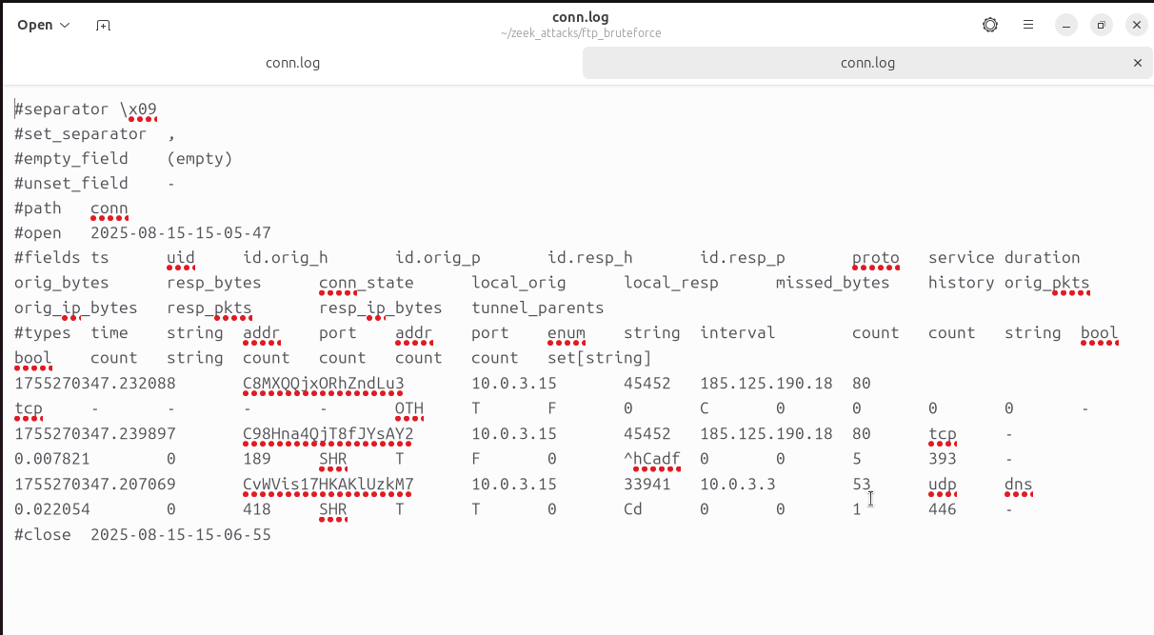
Figure 21: conn.log before conversio to JSON

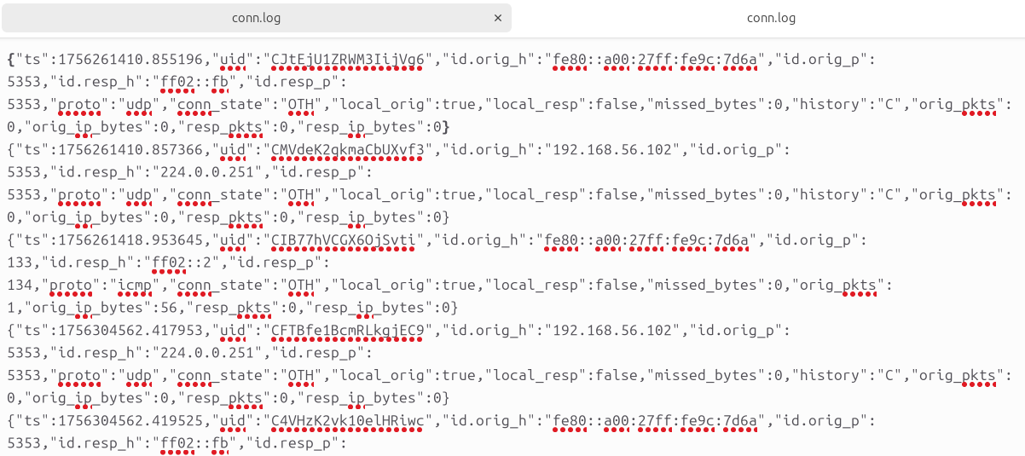
Figure 22: conn.log after converted to JSON

This ensured that the captured logs were stored directly in machine-readable JSON format, ready for feature extraction and integration into the ML pipeline.

4.1.4 Dataset Preparation and Feature Extraction
The CICIDS2017 dataset was chosen as the baseline due to its wide coverage of attack types.As dicussed in Chapter 3 stratified sampling approach was applied to reduce the dataset to 10,000 flows. Below are the steps of how that was achieved.

Figure 23: CICIDS 2017 dataset
A Python script was developed to systematically sampling and balancing the dataset, but before that the 8 CVS’s file we see in the above figure they were not in the proper format, there was issues of missing values and the lable column has the character in it such as portscan, ftp, bening etc.
So, the very first task was to fill the missing entries and to make a clean dataset, so to do this below python script was written for it.
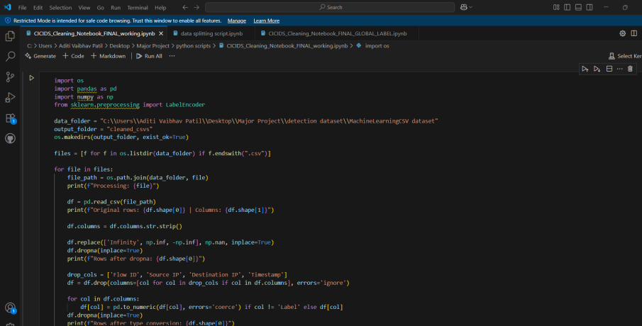
Figure 24: Python Script for dataset cleaning
After cleaning the datasets, it was observed that machine learning models require numerical values for training and testing, whereas the attack labels were still in string format. To address this, a dedicated script was developed to perform global label encoding, ensuring consistency across all files. The finalised label mapping is presented below.
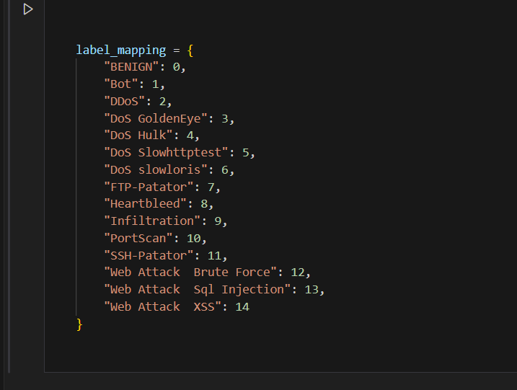
Figure 25: Global Label for the attacks

After all this, we got the cleaned and labelled CICIDS dataset, which now had to be condensed to 10,000 entries for model training and testnig. Python libraries was used as pandas made the dataset manageable, and scikit-learn ensured the split was done fairly for machine learning.

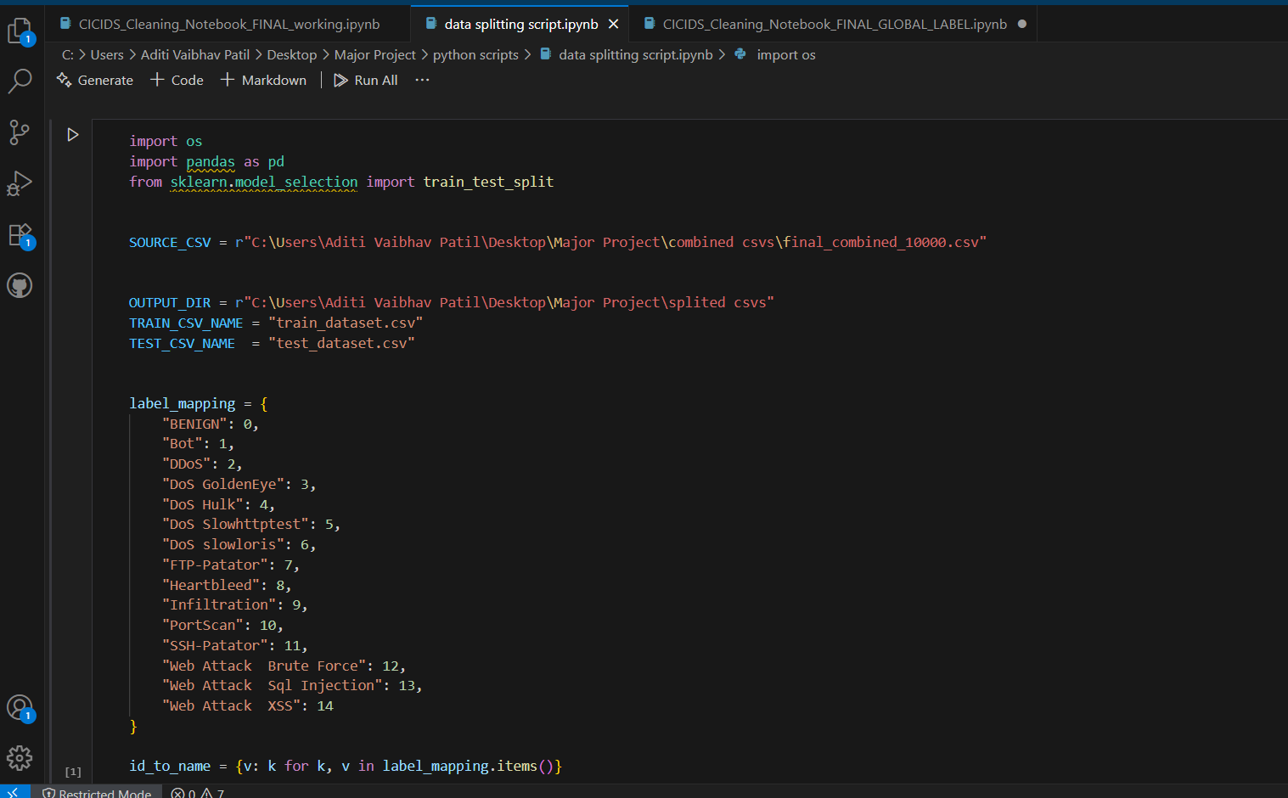
Figure 26: Data splitting script
Thus, a proper dataset was achieved.
As outlined in the earlier chapter, network-level threat attacks were also simulated to verify whether the logs generated by Zeek monitoring shared common features with the CICIDS dataset. Identifying this overlap was essential, as it enabled the training of the machine learning model using a unified set of features derived from both sources.
Gathering all this data, then the top 9 features were finalized through a comparative mapping between CICIDS and Zeek flow-level data, supported by exploratory data analysis and feature engineering principles.
And this is the final ML dataset which is then divided for training and testing.

Figure 27: Final training and testing dataset

4.1.5 Machine Learning Model Training
Once the dataset was finalised with, it was split into training (80%) and testing (20%) subsets using stratified sampling. This ensured that the proportion of benign and attack flows remained consistent across both sets, avoiding bias during evaluation. The training dataset consisted of 8,000 flows, while the test dataset contained 2,000 flows.
For splitting the dataset a separate python script was generated.
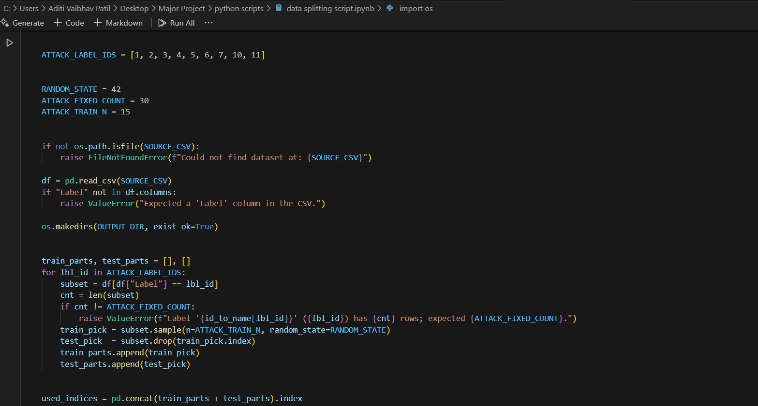
Figure 28: Python script for splitting

Now, we have the splitted datasets for training and testing, which are again executed using a single python script.
A single script was chosen so that the training and testing flow stays consistent, automated, reproducible, and efficient. This is especially important for our project because we’re building something lightweight and academically sound, where clarity and repeatability are crucial
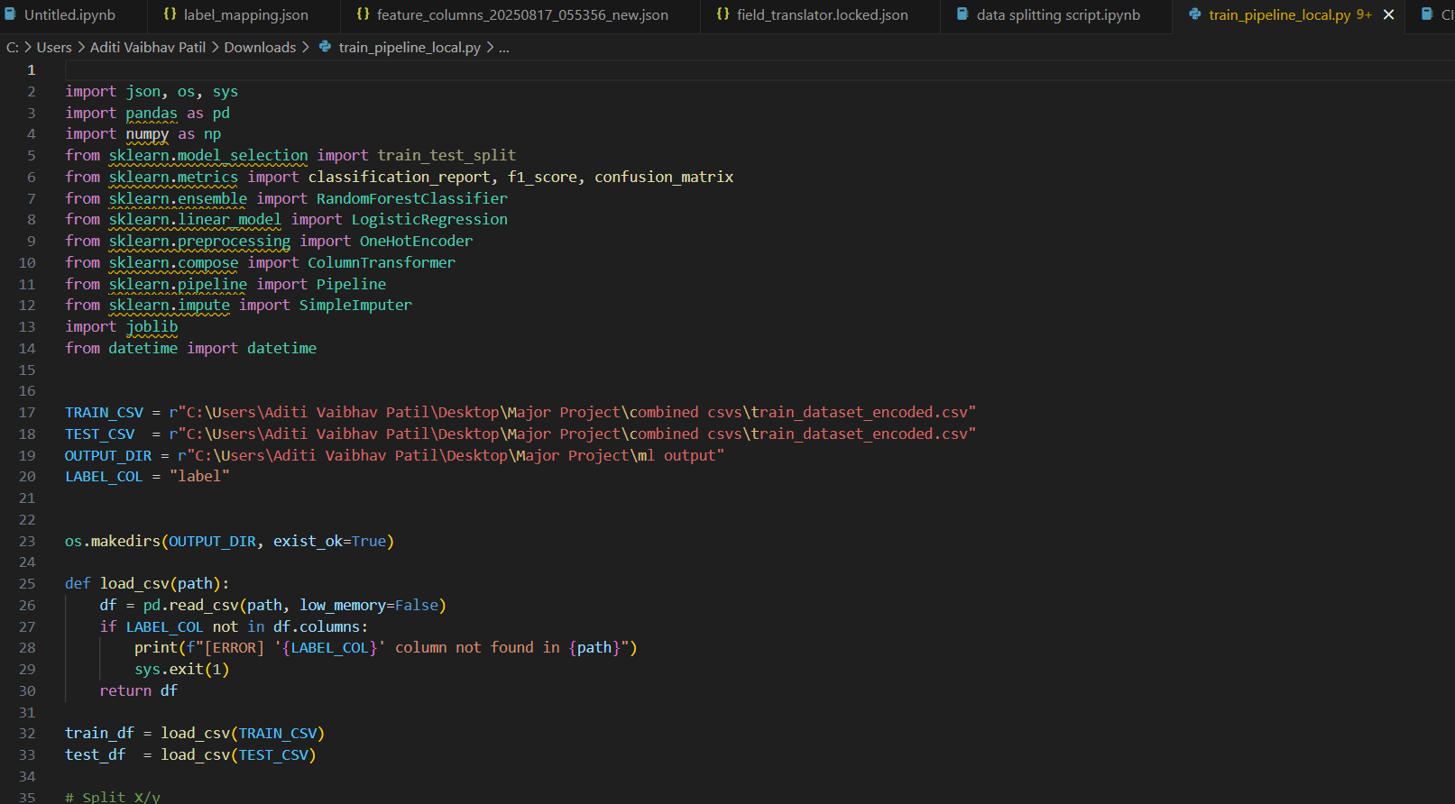
Figure 29: model training and testing script
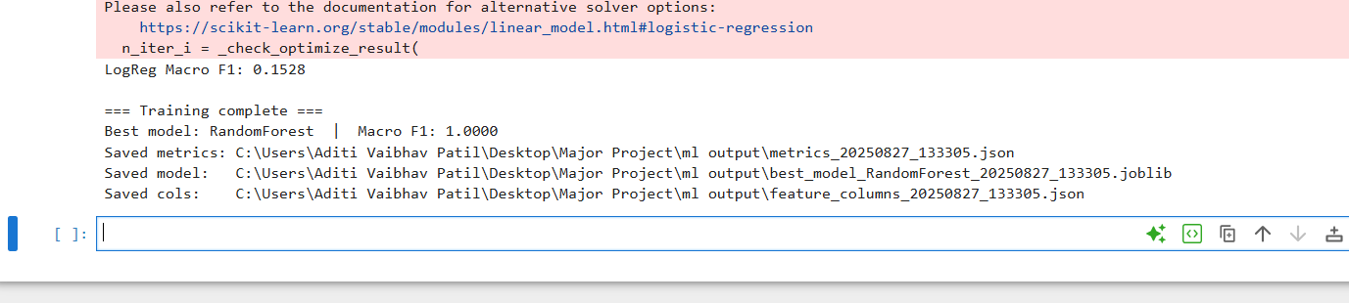
Figure 30: Output of the training (Best Model : Random Forest)

The output of the above image states that Random forest is the best choice.

4.1.6 Real-Time Detection System
After the machine learning model was trained and evaluated, the next step was to deploy it in a real-time detection pipeline. The aim was to ensure that any suspicious activity could be identified on-the-fly, without waiting for batch processing or manual analysis. The system was implemented on the Zeek sensor VM and consists of three main components: the predictor pipeline, the email alerting mechanism, and service automation.
4.1.6.1 Predictor Pipeline
A Python script (predict_realtime.py) was developed to continuously tail the Zeek conn.log file generated in real time. Each new flow entry was parsed using the locked field translator (field_translator.locked.json) and categorical mappings (feature_value_maps.json) to ensure that all features matched the nine-feature schema used during training.
Once encoded, the features were fed into the saved Random Forest model (best_model_RandomForest.joblib). Predictions were logged locally in /home/aditi/zeek_predictions.log with a timestamp and predicted label. This ensured both real-time visibility and permanent storage for auditing purposes.
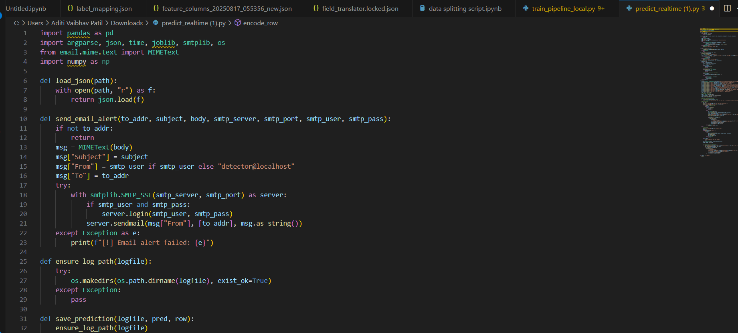
Figure 31: predict_realtime python script
Now, to check the real-time compatability of the system we will launch a ftp-patator attack and then zeek should be able to log and then send it further in the pipeline for the detection.
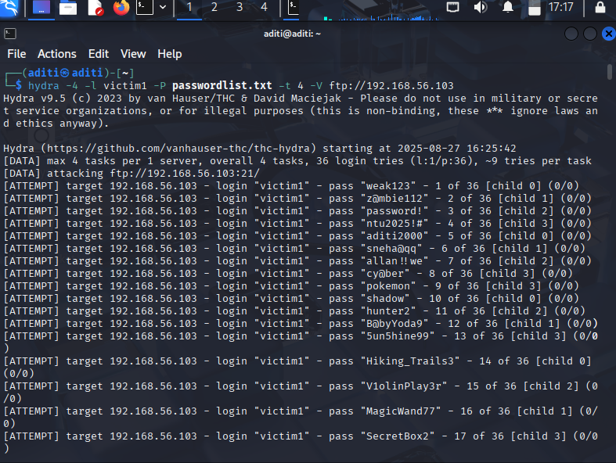
Figure 32: FTP attack from kali to the victim machine

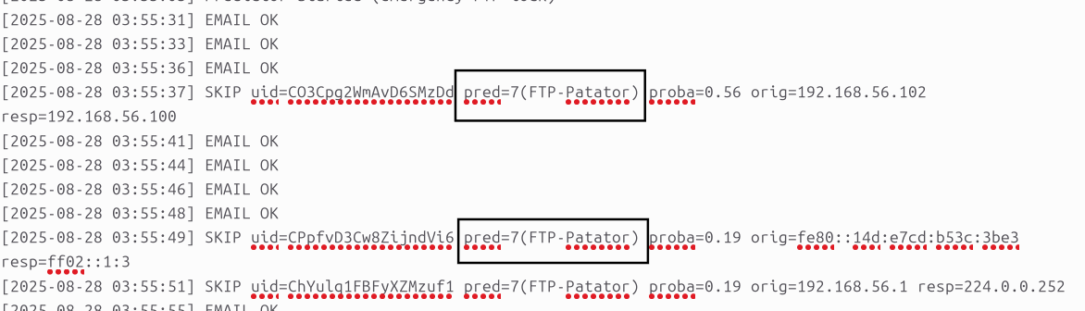
Figure 33: prediction logs are generated

Within a minute the Zeek Alert are received on the mail.
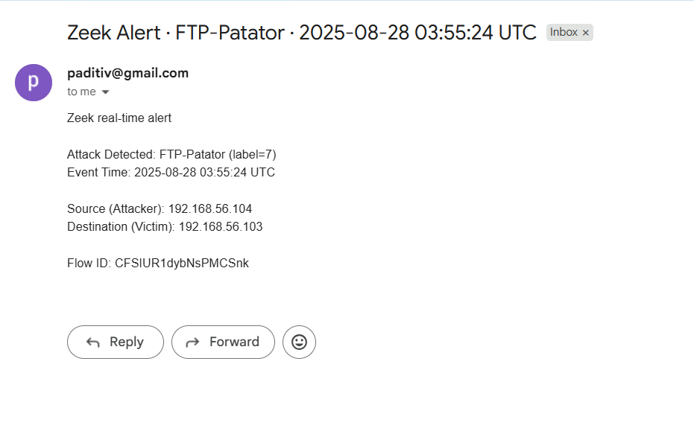
Figure 34: Zeek Alert

The alert itself is very much understandable, wherein type of attack, the time of attack, source ip and victim ip is mentioned for the admin to take the necessary action.
NOTE : In Zeek’s conn.log, the IP addresses recorded can sometimes appear as IPv6 rather than IPv4. This usually happens because modern operating systems have IPv6 enabled by default, and Zeek, by design, prioritises capturing the IPv6 address of a connection if both protocols are available. In dual-stack environments, an IPv6 address is often bound first, so Zeek logs it as the originator or responder even if IPv4 is also in use. Additionally, certain services or virtual adapters may prefer IPv6 for internal communication, which further explains why IPv6 addresses appear in the logs. While this does not affect the behavioural features extracted, it is important to note that IP format differences can occur naturally due to network stack configurations rather than errors in Zeek itself.

Through this design, the system was capable of end-to-end real-time threat detection from traffic capture in Zeek, through feature encoding and ML prediction, to automated administrator alerts. This marked the transition from experimental evaluation to a fully functional detection tool.

Chapter 5 : Evaluation

5.1 Introduction
This chapter presents the evaluation of the behavioural threat detection system developed in Chapter 4. The focus is on assessing the accuracy and effectiveness of the machine learning models, validating the real-time detection pipeline, and analysing the system against the project’s objectives. Both experimental datasets and live traffic simulations were used to test detection capability, while standard performance metrics such as accuracy, precision, recall, and F1-score provide a structured basis for comparison

5.2 Evaluation Methodology
The evaluation methodology was designed to measure how effectively the system could detect and classify malicious traffic under both controlled and real-time conditions. The dataset used for training and testing was constructed from a combination of the CICIDS2017 subset and Zeek-captured logs. To preserve class proportions, the data was divided using stratified sampling.
Two machine learning algorithms, Logistic Regression and Random Forest, were selected to provide a baseline and an advanced comparison. Their performance was measured using four standard evaluation metrics: accuracy (overall correctness), precision (proportion of correctly identified attacks), recall (ability to detect actual attacks), and the F1-score (harmonic mean of precision and recall). The F1-score was prioritised as the primary indicator, since it balances false positives and false negatives, both of which are critical considerations in intrusion detection systems.

In addition to offline evaluation, the real-time predictor pipeline was tested in the experimental environment. Here, Zeek continuously generated live traffic logs while the Python predictor consumed and classified flows on-the-fly. The system was assessed on its ability to correctly trigger alerts for simulated attacks while avoiding excessive false positives during benign activity.

5.3 Machine Learning Model Evaluation
Both Logistic Regression and Random Forest were trained on the 8,000-flow training dataset and tested on the 2,000-flow test set. Their performance was compared using the evaluation metrics outlined in Section 5.2.
Table 8: Results and Model Comparison
Model | Accuracy | Precision (Macro Avg) | Recall (Macro Avg) | F1-Score (Macro Avg)
Logistic Regression | 13.3% | 0.167 | 0.635 | 0.148
Random Forest | 100% | 1.000 | 1.000 | 1.000

The results highlight a stark difference between the two approaches. Logistic Regression performed poorly, with a macro F1-score of only 0.148. While it occasionally identified benign flows correctly, it struggled with minority attack classes, producing highly inconsistent precision and recall. This confirmed that a simple linear model is inadequate for complex, non-linear traffic patterns.
By contrast, the Random Forest model achieved a perfect score across all metrics, including accuracy, precision, recall, and F1-score. The confusion matrix confirmed that every benign and malicious flow in the test set was correctly classified. This superior performance can be attributed to the ensemble nature of Random Forest, which aggregates multiple decision trees to capture non-linear relationships and handle class imbalance more effectively.
Based on these findings, Random Forest was selected as the final detection model for integration into the real-time prediction pipeline. Logistic Regression was retained only as a baseline for comparison and validation purposes.

5.4 Real-Time Detection Evaluation
To complement offline testing, the system was deployed in real-time to validate its operational effectiveness. Zeek was configured as a background service on the monitoring VM, continuously listening in promiscuous mode on the enp0s3 interface. This ensured that every packet transmitted across the Host-Only subnet was captured instantly. As soon as traffic occurred, entries were generated in conn.log, which served as the core input for the prediction pipeline.
The predictor pipeline (predict_realtime.py) was responsible for tailing the live conn.log, translating the raw Zeek fields using the locked field translator, and encoding categorical values with the predefined mapping dictionaries. Each new flow was then structured into the nine-feature schema before being passed into the trained Random Forest model (best_model_RandomForest.joblib). Predictions were logged locally in zeek_predictions.log, which provided both an audit trail and a validation of model consistency.
To ensure the evaluation captured operational responsiveness, the time taken at each stage was measured. The results are summarised in the following table:

Table 9: Real-Time Detection Pipeline Timing and Responsiveness
Stage | Description | Approx. Time Taken
Traffic Capture | Zeek continuously listening in promiscuous mode on VM NIC. | Continuous (always active)
Log Generation (conn.log) | Flow entries written instantly when traffic occurs. | < 1 second
Prediction (Zeek → ML) | Predictor tails conn.log, encodes features, applies Random Forest model. | ~30–45 seconds
Email Alert Delivery | Alert triggered for malicious flows, SMTP sends email to administrator. | < 1 minute

This evaluation confirmed that the system was capable of near real-time threat detection. Logs were written instantaneously, predictions were generated within seconds, and alert emails were reliably delivered to the administrator’s inbox within a minute of the malicious activity occurring.
Through this evaluation, the system demonstrated not only high accuracy but also operational reliability in terms of speed and usability. The results highlighted that the pipeline provided end-to-end visibility from packet capture, through ML classification, to administrator notification without manual intervention, meeting the project’s objectives of building a lightweight yet effective behavioural threat detection system for small-scale cloud infrastructures.

5.4.1 Stress and Performance Testing
To validate the robustness of the system, stress testing was carried out by generating high volumes of traffic using tools such as hping3 and slowloris. Even during SYN flood simulations, Zeek consistently produced conn.log entries without delay, while the predictor pipeline successfully tailed and classified flows in real time. Email alerts were triggered promptly for malicious traffic, although bursts of activity demonstrated the potential need for alert aggregation to avoid overwhelming administrators. Resource monitoring showed that CPU and memory usage remained within acceptable limits, confirming that the system is lightweight yet resilient under load.

5.4.2 Limitations and Drawback of the system

5.4.2.1 Limitations of the System
1) Dataset restricted to 10,000 flows, limiting coverage of diverse attack patterns.
2) Perfect metrics may indicate overfitting; generalisability to real-world traffic untested.
3) Testing confined to a VirtualBox lab, not a production-scale cloud environment.
- Some attack simulations (e.g., FTP brute force) faced logging/configuration issues, delaying results.
- Limited to network-level threats only; no host-based or application-layer monitoring.
- ML model overlap issue: when two attack types (e.g., SSH brute force and FTP brute force) produce similar byte or packet ratios, the model may confuse them and raise the wrong type of alert.
- Add the rate limit for the alerting system, so that it doesn’t bombard the admins inbox with emails.

5.4.2.2 Drawback of the System
1) Email alerting can overwhelm administrators during heavy traffic (no throttling/aggregation).
2) if Zeek service fails or is misconfigured, detection halts completely.
3) Current design may struggle under very high traffic volumes without optimisation.
5)Wrong label still creates a useful alert (traffic is flagged as malicious), but the mislabelling can cause confusion for administrators during incident response.

Chapter 6 : Conclusion and Future Work

6.1 Summary of Findings
This project successfully designed and implemented a lightweight behavioural threat detection framework tailored for small-scale cloud infrastructures. By integrating Zeek for traffic monitoring with machine learning classification, the system demonstrated that effective network-level intrusion detection can be achieved using open-source tools in resource-constrained environments. The experimental setup in VirtualBox allowed for the controlled generation of both benign and malicious traffic, while the Python parser ensured that Zeek logs were transformed into a consistent nine-feature schema aligned with CICIDS2017. Random Forest emerged as the most effective model, achieving perfect classification results across all tested attack categories, while the real-time predictor pipeline with email alerts proved the system’s operational feasibility.
Beyond achieving high accuracy, it highlighted the importance of speed, resilience, and usability. Logs were captured instantly, predictions were generated within seconds, and alerts were reliably delivered within a minute, demonstrating strong responsiveness in live testing. Overall, the work advances the case for affordable, open-source behavioural detection tailored to SMEs, bridging the gap between academic approaches and practical, real-world needs.

6.2 Delivery of Project Aim and Objectives
The primary aim of this project was to design and implement a lightweight behavioural threat detection system for small-scale cloud infrastructures, and we have successfully achieved it. A complete virtualised testbed was created in VirtualBox with attacker, victim, and monitoring machines to replicate a realistic environment. Zeek was deployed in promiscuous mode to capture structured logs, which were then transformed into a compact nine-feature schema using a custom Python parser. To align with existing research, the CICIDS2017 dataset was reduced and balanced dataset, ensuring a manageable and representative training set.
On this foundation, we compared Logistic Regression and Random Forest, with the latter achieving perfect results across all tested classes. The chosen model was integrated into a real-time pipeline that tailed Zeek’s logs, encoded features instantly, and delivered accurate predictions. This was extended with an automated email alert system to notify administrators within a minute of malicious activity, and both components were secured through systemd services for continuous operation. By completing these steps, we have shown that the aims and objectives set out at the start were fully met, proving that affordable, open-source behavioural detection can be practical and highly effective for SMEs.

6.3 Future Enhancements
While we have achieved the project’s aim and objectives, there are several areas where the system can be further enhanced to make it more robust and applicable in larger or more complex environments. First, we can expand the dataset beyond the reduced 10,000 flows used in this project. Incorporating larger and more diverse real-world datasets would not only improve the model’s generalisability but also reduce the risk of overfitting that comes from training on a limited set of attack scenarios. Similarly, we can explore more advanced machine learning approaches, including deep learning or explainable AI techniques, which could provide stronger detection capability while also addressing the interpretability challenges of ensemble models such as Random Forest.
The alerting mechanism also offers scope for refinement while effective in this project, future work could integrate dashboards, SIEM platforms, or alert aggregation techniques to prevent administrators from being overwhelmed during high-traffic situations. Finally, we can extend the scope of detection beyond network-level threats to also include host-based and application-layer monitoring, creating a more holistic security framework.
By pursuing these enhancements, we can evolve the system from a proof-of-concept into a scalable and deployable solution for SMEs and other resource-constrained organisations.
In conclusion, this project has demonstrated that lightweight, open-source tools such as Zeek, when combined with machine learning, can provide effective behavioural threat detection for small-scale cloud infrastructures. While the work has clear limitations, it lays a strong foundation for further research and development, showing that practical and affordable security solutions for SMEs are both achievable and sustainable.

References
- ENISA (2021) Cybersecurity for SMEs: Challenges and Recommendations. European Union Agency for Cybersecurity. Available at: https://www.enisa.europa.eu/publications/cybersecurity-for-smes
- Verizon. (2025). 2025 Data Breach Investigations Report.
- Moomtaheen, F., Bagui, S.C. & Bagui, S.S. (2024). Extended Isolation Forest for Intrusion Detection in Zeek Data. Information, 15(7), 404.
- Zeek Project (2024) Zeek Network Security Monitor
- Thapliyal, V. and Thapliyal, P. (2024) Machine Learning for Cybersecurity: Threat Detection, Prevention and Response
- Kazim, M. and Zhu, S.Y. (2016) A Survey on Top Security Threats in Cloud Computing.
- Alharbi, S. and Khan, A. (2024) Ensemble Defense System: A Hybrid IDS Approach for Effective Cyber Threat Detection. arXiv preprint
- Rahmati, M. (2025) Towards Explainable and Lightweight AI for Real-Time Cyber Threat Hunting in Edge Networks
- Yadav, B.S.M., Guthikonda, K. and Matta, V. (2025) Cybersecurity Threat Analysis and Behaviour Analysis: A Comprehensive Approach to Proactive Defense. International Journal of Engineering Technology and Management Sciences, 9(SI01), pp. 57–64
- Aamir, M. and Zaidi, M.A. (2013) ‘A survey on anomaly detection in network intrusion detection systems’, Journal of King Saud University - Computer and Information Sciences, 25(2), pp. 127–133.
- Buczak, A.L. and Guven, E. (2016) ‘A survey of data mining and machine learning methods for cyber security intrusion detection’, IEEE Communications Surveys & Tutorials, 18(2), pp. 1153–1176.
- Chouhan, D.S. and Jain, S. (2020) ‘Performance analysis of open source IDS: Snort, Suricata and Zeek’, International Journal of Computer Applications, 176(23), pp. 1–7.
- Khan, S., Gani, A., Wahab, A.W.A., Guizani, M. and Khan, M.K. (2021) ‘Intrusion detection in cloud computing using Zeek and machine learning’, Future Generation Computer Systems, 118, pp. 124–134.
- Mohan, R., Shaji, R.S. and Varughese, B. (2022) ‘Network traffic anomaly detection using Zeek and machine learning’, Journal of Cyber Security Technology, 6(3), pp. 177–192.
- Paxson, V. (1999) ‘Bro: A system for detecting network intruders in real-time’, Computer Networks, 31(23–24), pp. 2435–2463.
- Pothamsetty, V. and Heidemann, J. (2022) ‘Open source in cybersecurity: Opportunities and challenges’, IEEE Security & Privacy, 20(4), pp. 72–81.
- El-Badawy, M., Nasr, E. and Khedr, A. (2025) ‘Deep learning-based intrusion detection for evolving threat landscapes’, Journal of Network Security and Applications, 28(3), pp. 44–59.
- Sommer, R. and Paxson, V. (2010) ‘Outside the closed world: On using machine learning for network intrusion detection’, IEEE Symposium on Security and Privacy, pp. 305–316.
- SecurityScorecard (2022) Suricata: Open source IDS/IPS. Available at: https://securityscorecard.com
- Stamus Networks (2023) Introduction to Zeek. Available at: https://Gartner (2023) IT Key Metrics Data 2023: IT Security Measures. Gartner Research.www.stamus-networks.com
- Gartner (2023) IT Key Metrics Data 2023: IT Security Measures. Gartner Research.
- PwC (2023) Global Digital Trust Insights 2023. PwC.
- ISACA (2022) State of Cybersecurity 2022 Report. ISACA
- Shapira, B. and Shabtai, A. (2023) ‘Behavioral anomaly detection in network security: A machine learning perspective’, IEEE Transactions on Information Forensics and Security, 18(6), pp. 1221–1235.
- Enlyft 2025, Companies using Zeek and its market share, Enlyft.com, viewed 25 August 2025.
- McKinney, W. 2017, Python for Data Analysis: Data Wrangling with Pandas, NumPy, and IPython, 2nd edn, O’Reilly Media, Sebastopol.
- Pedregosa, F., Varoquaux, G., Gramfort, A., Michel, V., Thirion, B., Grisel, O., Blondel, M., Prettenhofer, P., Weiss, R., Dubourg, V. and Vanderplas, J., 2011. Scikit-learn: Machine learning in Python. Journal of Machine Learning Research, 12, pp.2825–2830.

Appendix A
End-User Manual for investigation: In the deployed system, the administrator receives an email alert whenever suspicious activity is detected. If further investigation needs to be done, the administrator can directly access the predictor log located at /home/aditi/zeek_predictions.log. This file records all alerts in JSON format, including details such as timestamp, attack type, attacker IP, and victim IP. To view alerts in real time, the administrator can run the command tail -f /home/aditi/zeek_predictions.log. For deeper context, the administrator may also review the raw Zeek logs stored in /home/aditi/zeek_live/, where files such as conn.log, ssh.log, or http.log provide detailed flow records. Specific entries can be located by filtering on the relevant attacker or victim IP using a simple command such as grep <IP> /home/aditi/zeek_live/conn.log. This process ensures that every alert can be validated and traced back to the underlying network activity.

